Loops

# design: WHile loops

The plan for the implementation is consistent with IfStatement, and there will be a new While class that extends token. It will also have a condition property, and a contents array. This new While token will be produced by “while” in make_identifier().

### evaluation

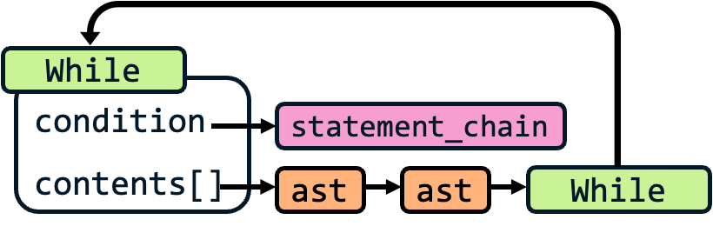Even though this is the final step, it most clearly explains how the while loop will operate. When evaluate() is called on the While token, it will evaluate() the condition to check if it is true. If it is true, it will return the value of contents, but the last item in contents will point to itself. This therefore means that when evaluate_asts() is called on the result of evaluate(), it will execute the contents, and then call the While loop again, to check for the condition again and allow another cycle.

This is a recursive way to deal with the issue, and I think is the simplest way to implement it, as separate checks for conditions and contents would complicate the Interpreter’s code in run() and evaluate_asts()

### A screenshot of a diagram Description automatically generatedparsing

🡺 build_while_loop()

The flowchart for this is similar, but much simpler than build_if_statement(). It also has iteration until currentTokens is null, but with less checks: only checking for endWhile where it simply returns the While token, otherwise it adds the parsed current line to contents.

Parsing the condition at the start is much simpler as well, so I have decided to include it in the same method, unlike for if statements which had the separate if_statement() method to parse these conditions.

This is due to not needing the “then” keyword largely, which significantly simplifies the checks that need to be added.

There will also have to be a lot more error checks included than presented in this flowchart, but they can easily be dealt with, like with if statements, by me trying lots of invalid inputs and implementing as many checks as I can to prevent them.

This plan is not very long, but a lot of the framework for implementing this feature is already in place, so it should be okay to start development.

# development: While loops

### basics

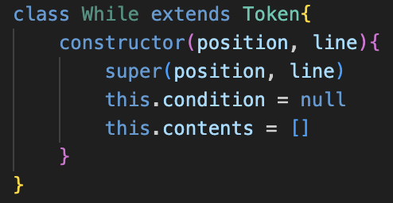A section in parse() also must be added to call the build method.

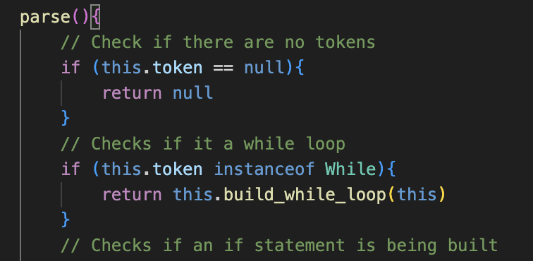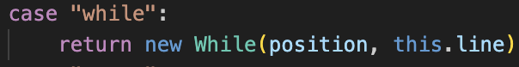

### build_while_Loops()

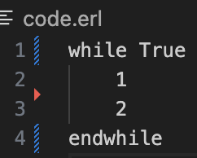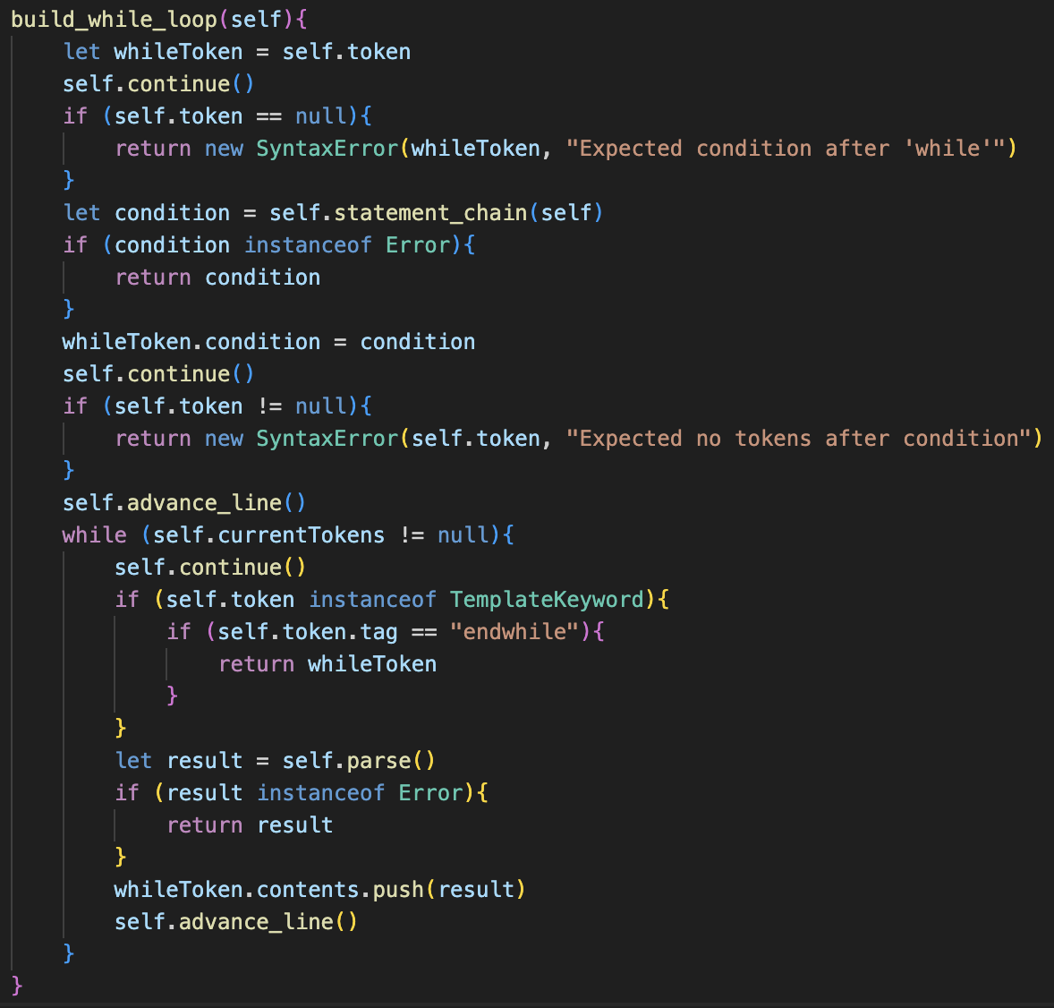This was my initial implementation of the method. I included a few error checks – for no condition being present as well as additional tokens after the condition (such as then).

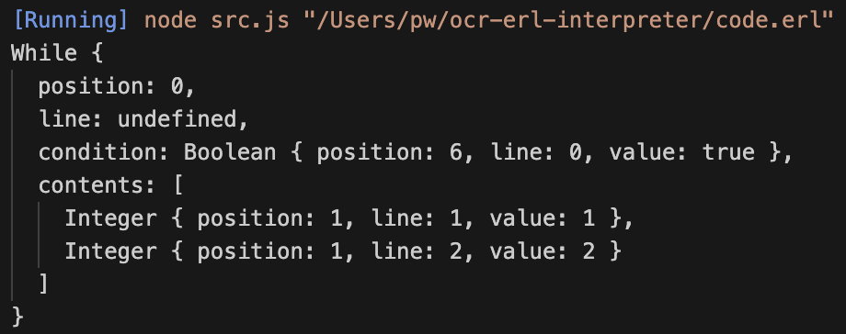Ignoring the undefined line property (due to a syntax error), the test case was successful and the While loops was built correctly.

### evaluation

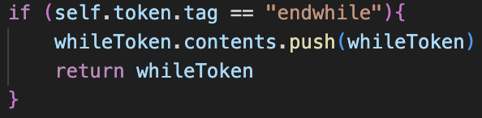I initially decided to add the While loop to itself in the endWhile check of build_while_loop(), by pushing itself to contents before returning itself.

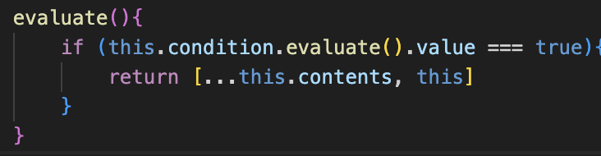However, I then decided to move it to the evaluate() method, as I felt like altering the contents is a potentially bad idea if the system needs to be reworked in the future, as well as the printed ast being more representative of the actual contents if it does not reference itself.

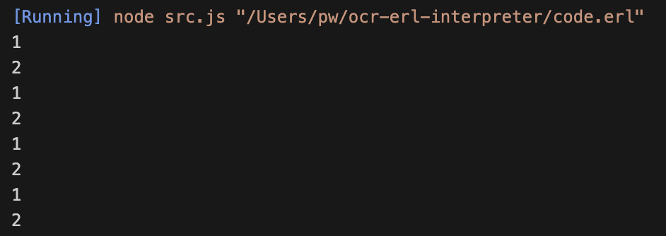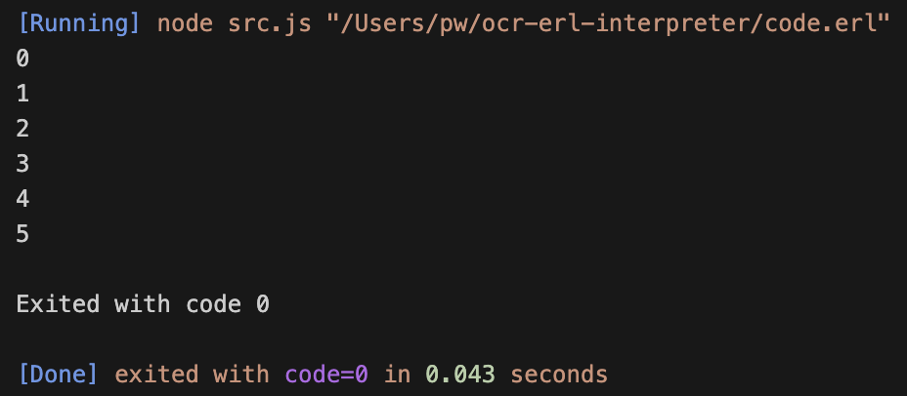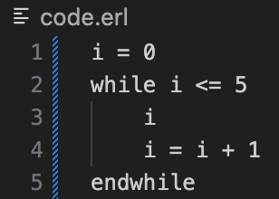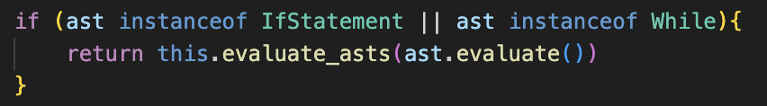Now by changing one line in evaluate_asts(), it meant that While loops were treated the same as IfStatements for the recursive calling.

The test case correctly worked, and when trying a more complex test involving identifier – like a counter-controlled loop – the expected result was still returned, proving that the implementation was a success.

However, there was one issue with this implementation.

## the call stack problem

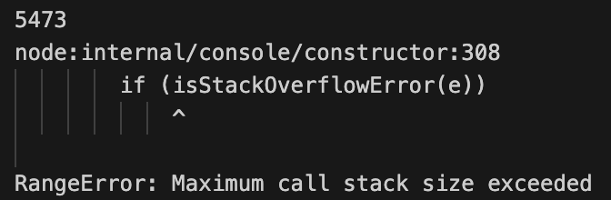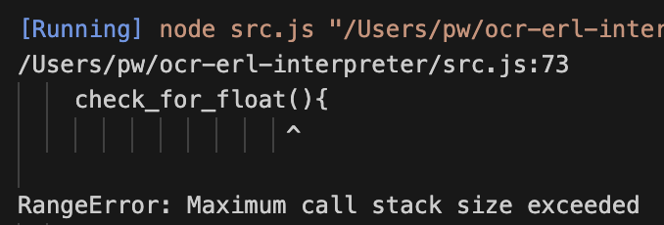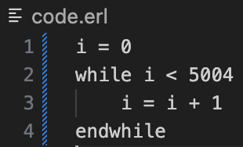Because the solution was implemented recursively, whenever the while loop approached around 5000 iterations or greater, a stack overflow error would occur as the maximum amount of recursion had been met.

Initially, I thought that this may not be a huge problem, due to GCSE questions never requiring this level of iteration. This would then require some sort of iteration cap, which I considered but then decided against.

Additionally, having an enormous call stack uses a lot of memory, and as the target user to for this project uses low-end school devices, optimising performance is important. Therefore, I decided to use a different approach to evaluating the While loops, using iteration rather than recursion.

### A screen shot of a computer code Description automatically generatedan iterative approach

The new approach now has two evaluate() methods: evaluate condition() for the condition and evaluate() for the contents.

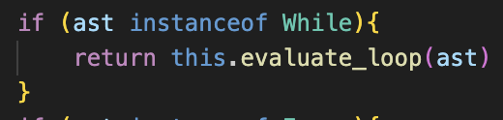I do not love having multiple evaluate() methods as it ruins the polymorphism, but because all 3 types of loops will be able to use this same system it is not a major issue.

evaluate_asts() now has a separate check for While (and in future the others) and will call a new method: evaluate_loop(), passing the loop ast to the method.

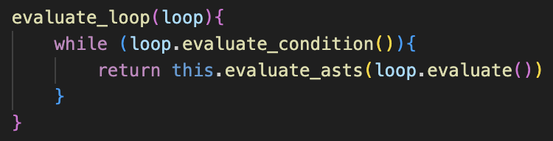This method will then repeatedly call evaluate_asts() on the loop’s contents while evaluate_condition() is true, therefore creating an iterative approach.

The naming could be changed in the future, as evaluate() is not a perfect description, however for now it is acceptable.

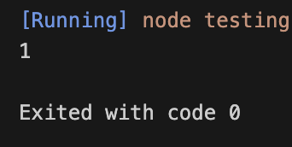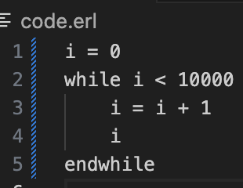Initially, the test case failed, but this is because I’d used return in evaluate_loops() so the first iteration would only ever occur.

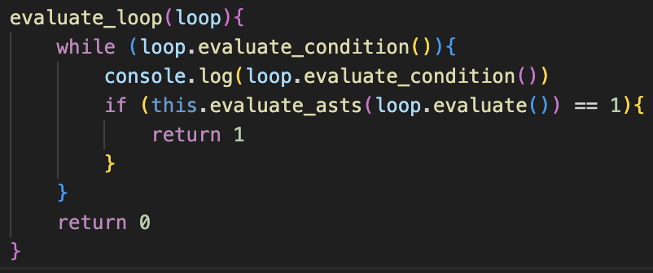I also realise I’d still need to check for errors and be able to exit the loop if one occurred, so using the 0/1 system, if the result of evaluate_asts() was ever 1, I would then exit out of the loop prematurely.

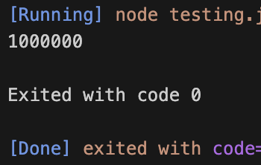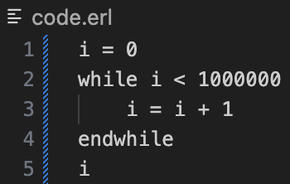From here, we now had no limit on the number of iterations.

## error handling

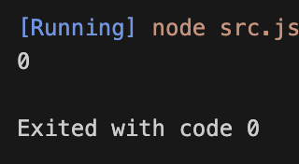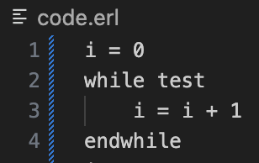**🡺 Error with condition**

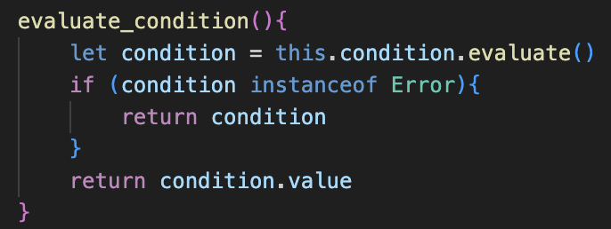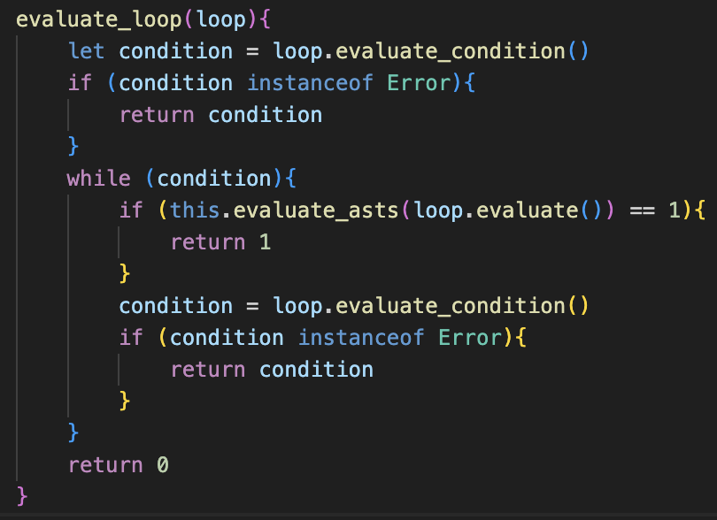Currently, if there is an error in the condition, it is not reported by the interpreter and instead some completely unexpected results are produced.

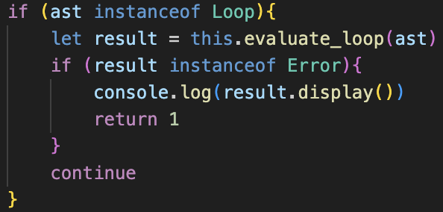This requires evaluate_condition() to be changed so that, if an error occurs, it will be returned. Therefore, evaluate_loop() must also be changed so that every time the condition is revaluated, there is a check for an error that can return the error if need be.

Then, evaluate_asts() must be able to catch these errors from evaluate_loop(), so it does not continue executing instructions after the error occurs, and can return out of the method.

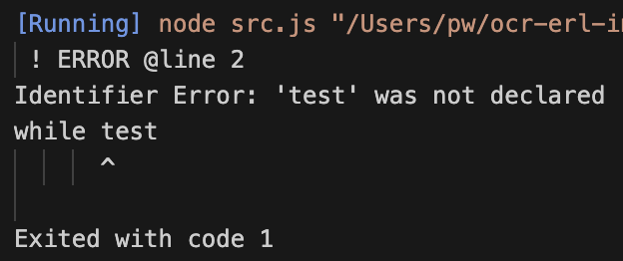I do not love this implementation, as sometimes integers are returned when errors occur and sometimes integers of 0/1 are returned, so there is not a lot of consistency which I think may result in issues, however for now this solution is acceptable and can be refined later.

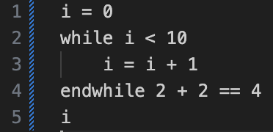🡺 **Tokens after endwhile**

Even though it doesn’t crash the program and simply ignores the tokens, I feel as if there should be an error message for clarity of code.

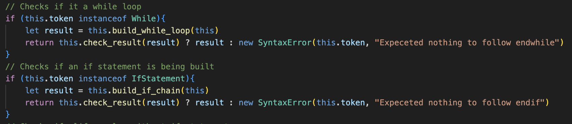I also added the change for endif as it did not currently have a check and could also have the same issue

The solution is by changing parse() to ensure that the current token is null after build_while_loop() or build_if_chain() are used, as that would catch any unexpected tokens.

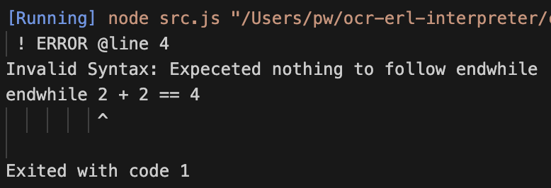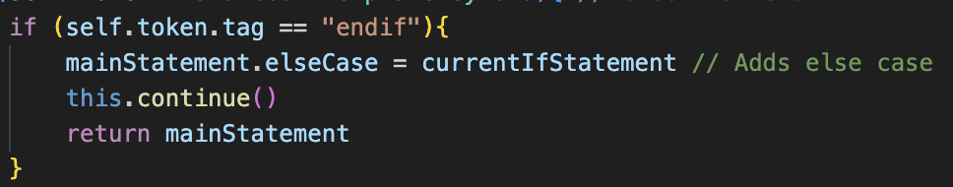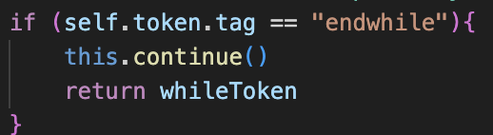The build methods also must be changed to call continue() before they return the token, but from there the error is correctly handled.

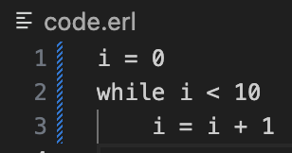**🡺 No endwhile**

A simple addition is needed after the iteration in build_while_loop(), identical to how it is implemented in build_if_chain().

### more error cases

These are only the errors involved with parsing, but I have not tested a lot of errors which involve nesting and cases which have errors within these structures.

I first, however, will implement the other 2 types of errors, and then return at the end to potentially redesign evaluate_asts() and run() as I am currently not happy with how the system operates, and am anticipating a lot of issues when I run a greater number of tests.

# design: do until loops

To reduce code repetition, there will now be a parent class for all Loops. Called Loop, While and the new Do class will extend it. All Loops will have the same attributes and evaluate() method, so these will be in the Loop class, with just a custom evaluate_condition() for each class.

As stated, Do will be the main token for do until loops, and it will be interacted with identically to the While loop in the Interpreter, with only the way it is constructed and its condition being different. It will be produced by “do” in make_identifier(), alongside a new TemplateKeyword: “until”.

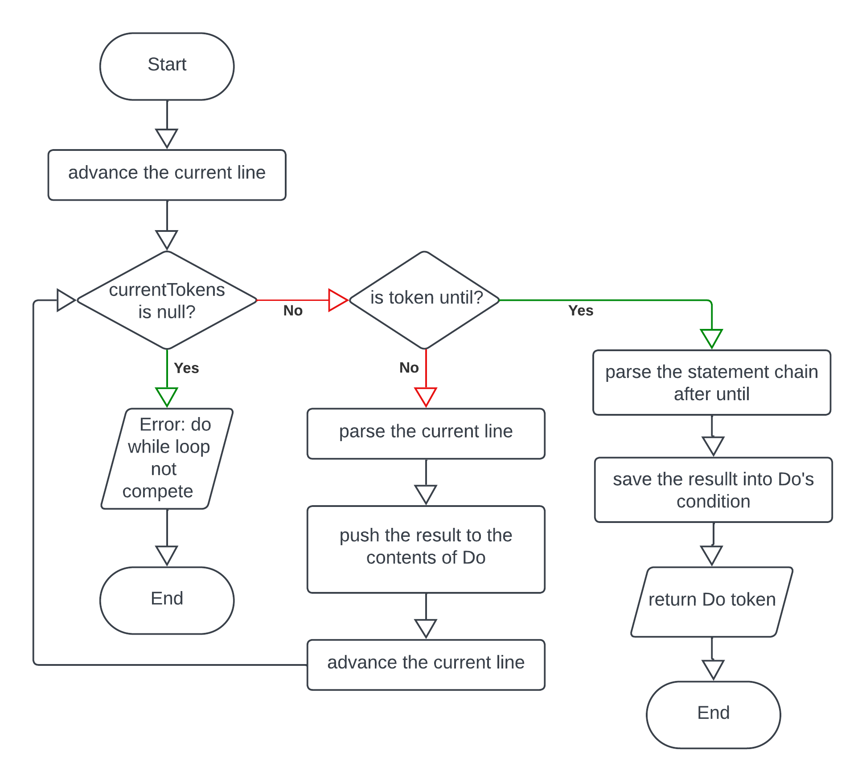🡺 make_do_loop()

This will be extremely like make_while_loop(), with the difference being that the statement chain will be at the end, after the closing keyword “until”, rather than after “do”. This means that most of the code should be the same, but with some changing of keywords and reshuffling of the order of the algorithm.

🡺 evaluate_condition()

This is where the main difference will be. Because all loops will be run using evaluate_loop() in the Interpreter, I want to avoid using a JavaScript do while loop as this requires extra case checks, and instead want to use a standard while loop for every type of loop the interpreter has.

The solution to this is ensuring that the first time the method is called it always returns true, regardless of the condition.

Therefore, an attribute called firstPass will be added, and will be assigned false in the constructor. Whenever evaluate_condition() is called, it will check if firstPass is false. If it is false, then it will be set to true, and true will be returned by the method. Therefore, every following time that evaluate_condition() is called, it will take the other, default branch and will return the value of evaluating condition.

### error handling

The benefit of this system is that is aligns with the pre-existing code, so only the new build_do_loop() will need to have checks for errors, which is very similar to build_while_loop(), and therefore the program will run seamlessly without any changes to the Interpreter.

# development: do until loops

### basics

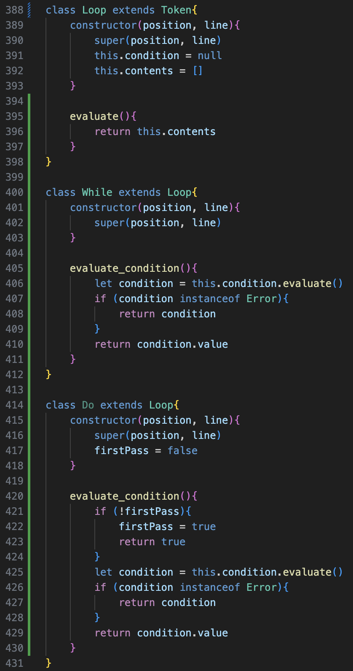The changes to while are shown on the left: the overall code is the same, but it is split across Loop as well .

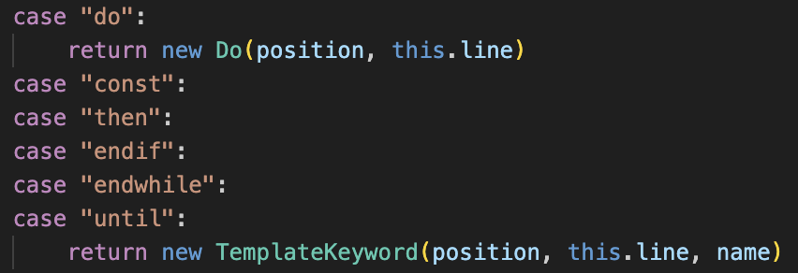Note that firstPass is not assigned as a property here, as it does not have the “this” keyword, so this was changed as otherwise it does not work.

### build_do_loop()

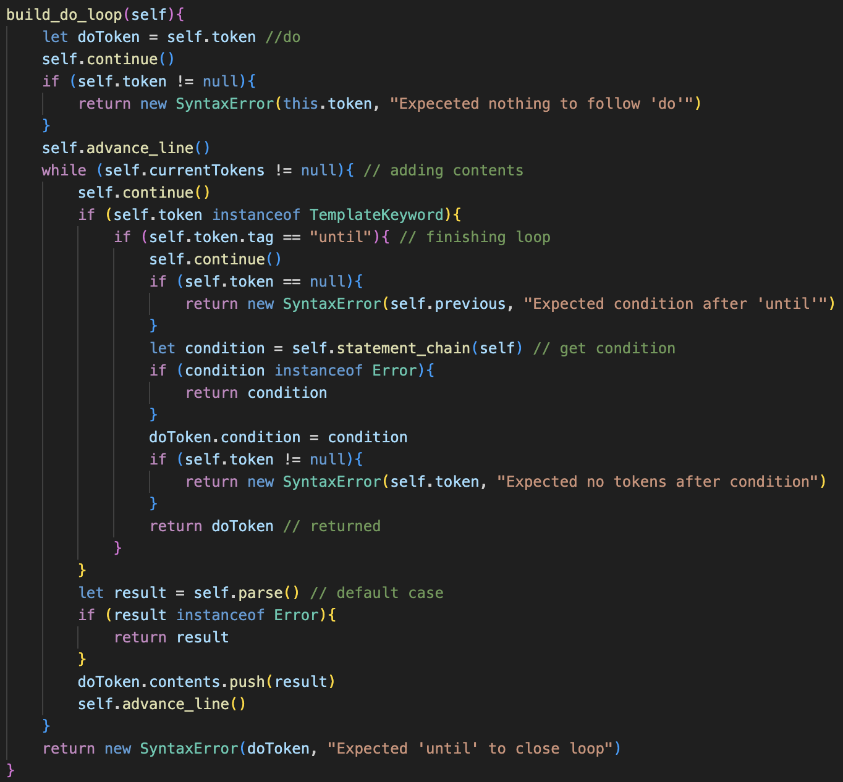The code from build_while_loop() was copy pasted and rearranged to form this method, as they are very similar.

This led to a lot of errors due to not renaming elements properly, such as not changing the tag check from “endwhile” to “until”, as well as still referencing whileToken in a lot of places or incorrectly named error messages.

The final version is shown on the left for simplification, as there were no major changes in its development.

### evaluation

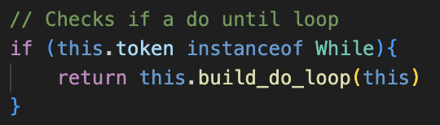Another line has to be added in parse() in order to call build_do_loop() when a Do token is encountered.

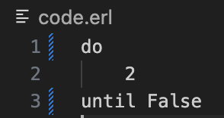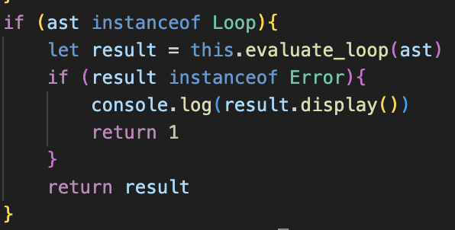Finally, the line in evaluate_asts() must be altered to call evaluate_loop() for any instance of Loop, not just While.

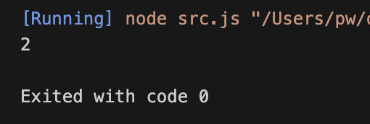From here, the test was semi-successful, running the loop only a single time, which would be the correct output it was until True, but it was until False.

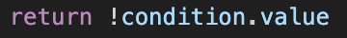This is because I have treated it like a do…while loop, rather than a do…until, where do until will run the contents when the condition is False, and stop when it is True, which is the opposite of what the current implementation did.

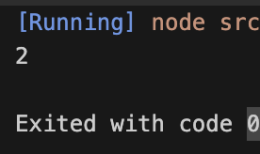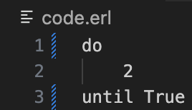However, this fix was easy: changing evaluate_condition() to return the NOT of the value, therefore a false evaluation would return true, so it would continue to run, and when it evaluated to True, false would be returned and the until would be fulfilled, and the loop would stop running.

Now the do until loop is successful and will run the until True loop a single time before exiting.

### error checking

When trying the possible cases, because the code had been based off the while loop code, all of the error cases from that had carried over, and therefore I could not find any occasions where Syntax Errors should be returned when they weren’t.

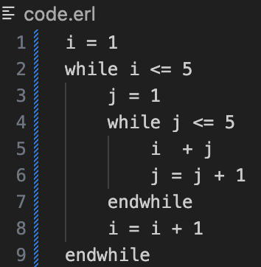The main issues were with the evaluation in the Interpreter code, so I trialled a few cases and the main issue was with nesting different loops.

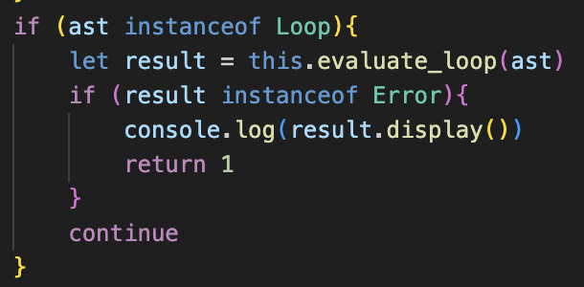The nested loops on the left continually printed 2,3,4,5,6; with the i value never incrementing. After a lot of debugging, it was due to the way return had been used within evaluate_asts(), and if the first ast was an instance of loop, then it would return out of the method before running the other lines, so the i = I + 1 line was fully ignored.

It’s a simple change, but makes me dislike the current Interpreter system even more.

### final changes

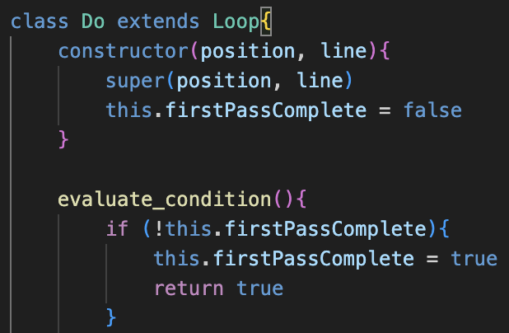Finally, I renamed the firstPass attribute to firstPassComplete, as I feel it is more descriptive and firstPass could potentially be confusing. I also updated this in evaluate_condition()

This concludes the section on Do loops, and now the final of the 3 loops can be implemented/

# design: for loops

This is the most complex of the three loops, due to the much larger number of potential inputs required and the structure having multiple different cases it can hold. There will be 3 new tokens for this module: the For token that extends Loop, and 3 new Template Keywords: “to”, “step” and “next”.

### for

As it extends the Loop class, it will adopt the previous attributes and evaluate() method, but will also have many other new properties:

assignment 🡺 holds the assignment ast to be evaluated for the first time  
variable 🡺 holds the identifier for the variable that is being iterated through and is set in assignment  
finish 🡺 holds the ast for the ending value of the for loop  
step 🡺 holds the step of the for loop with the default value being 1 if not stated  
firstPassComplete 🡺 a boolean, like used in Do to outline if the loop has iterated before

🡺 evaluate_condition()

If firstPassComplete is false, then it will be set to true and the assignment property will be evaluated(). If it is false then the variable property’s assign() method will be called to get the Data Type, and then set() will be called on that to increment the value by the value of step.

Then, the method will call evaluate() on the variable, and if the value is less than or equal to finish, it will return true, and will otherwise return false. It is important that it is less than or equal to because in ERL, for loops are inclusive with the finish value.

### A screenshot of a computer program Description automatically generatedparsing

As shown by the OCR specification on the right, the parsing for this stage will be more complex than the other loops due to the length of the first line in a for loop and the amount of detail it contains.

Overall, the BNF for a for loop is:

<for_loop> ::= For <assignment> “to” <expression>  
 (“step” <expression>)

Where the brackets () represent an optional element, so therefore step does not have to be specified, and defaults to 1.

Furthermore, the closing line of the for loop is defined as:

<for_end> ::= “next” Identifier

However, the name of the Identifier in <for_end> must match the name of the Identifier that is the left-hand child of <assignment> in <for_loop>, as it represents the variable incrementing.

When saved in the For instance, the <assignment> is stored in the assignment property, the left hand of that is stored in the variable property, the first <expression> is stored in finish, and the final, optional <expression> is stored in the step attribute.

🡺 build_for_loop()

This is the method that will build the for loops based on the BNF and will be called in parse() when the For token is the first token in a line. This will follow the same general structure as the others, consisting of the big while currentTokens != null loop which repeatedly adds the lines to contents.

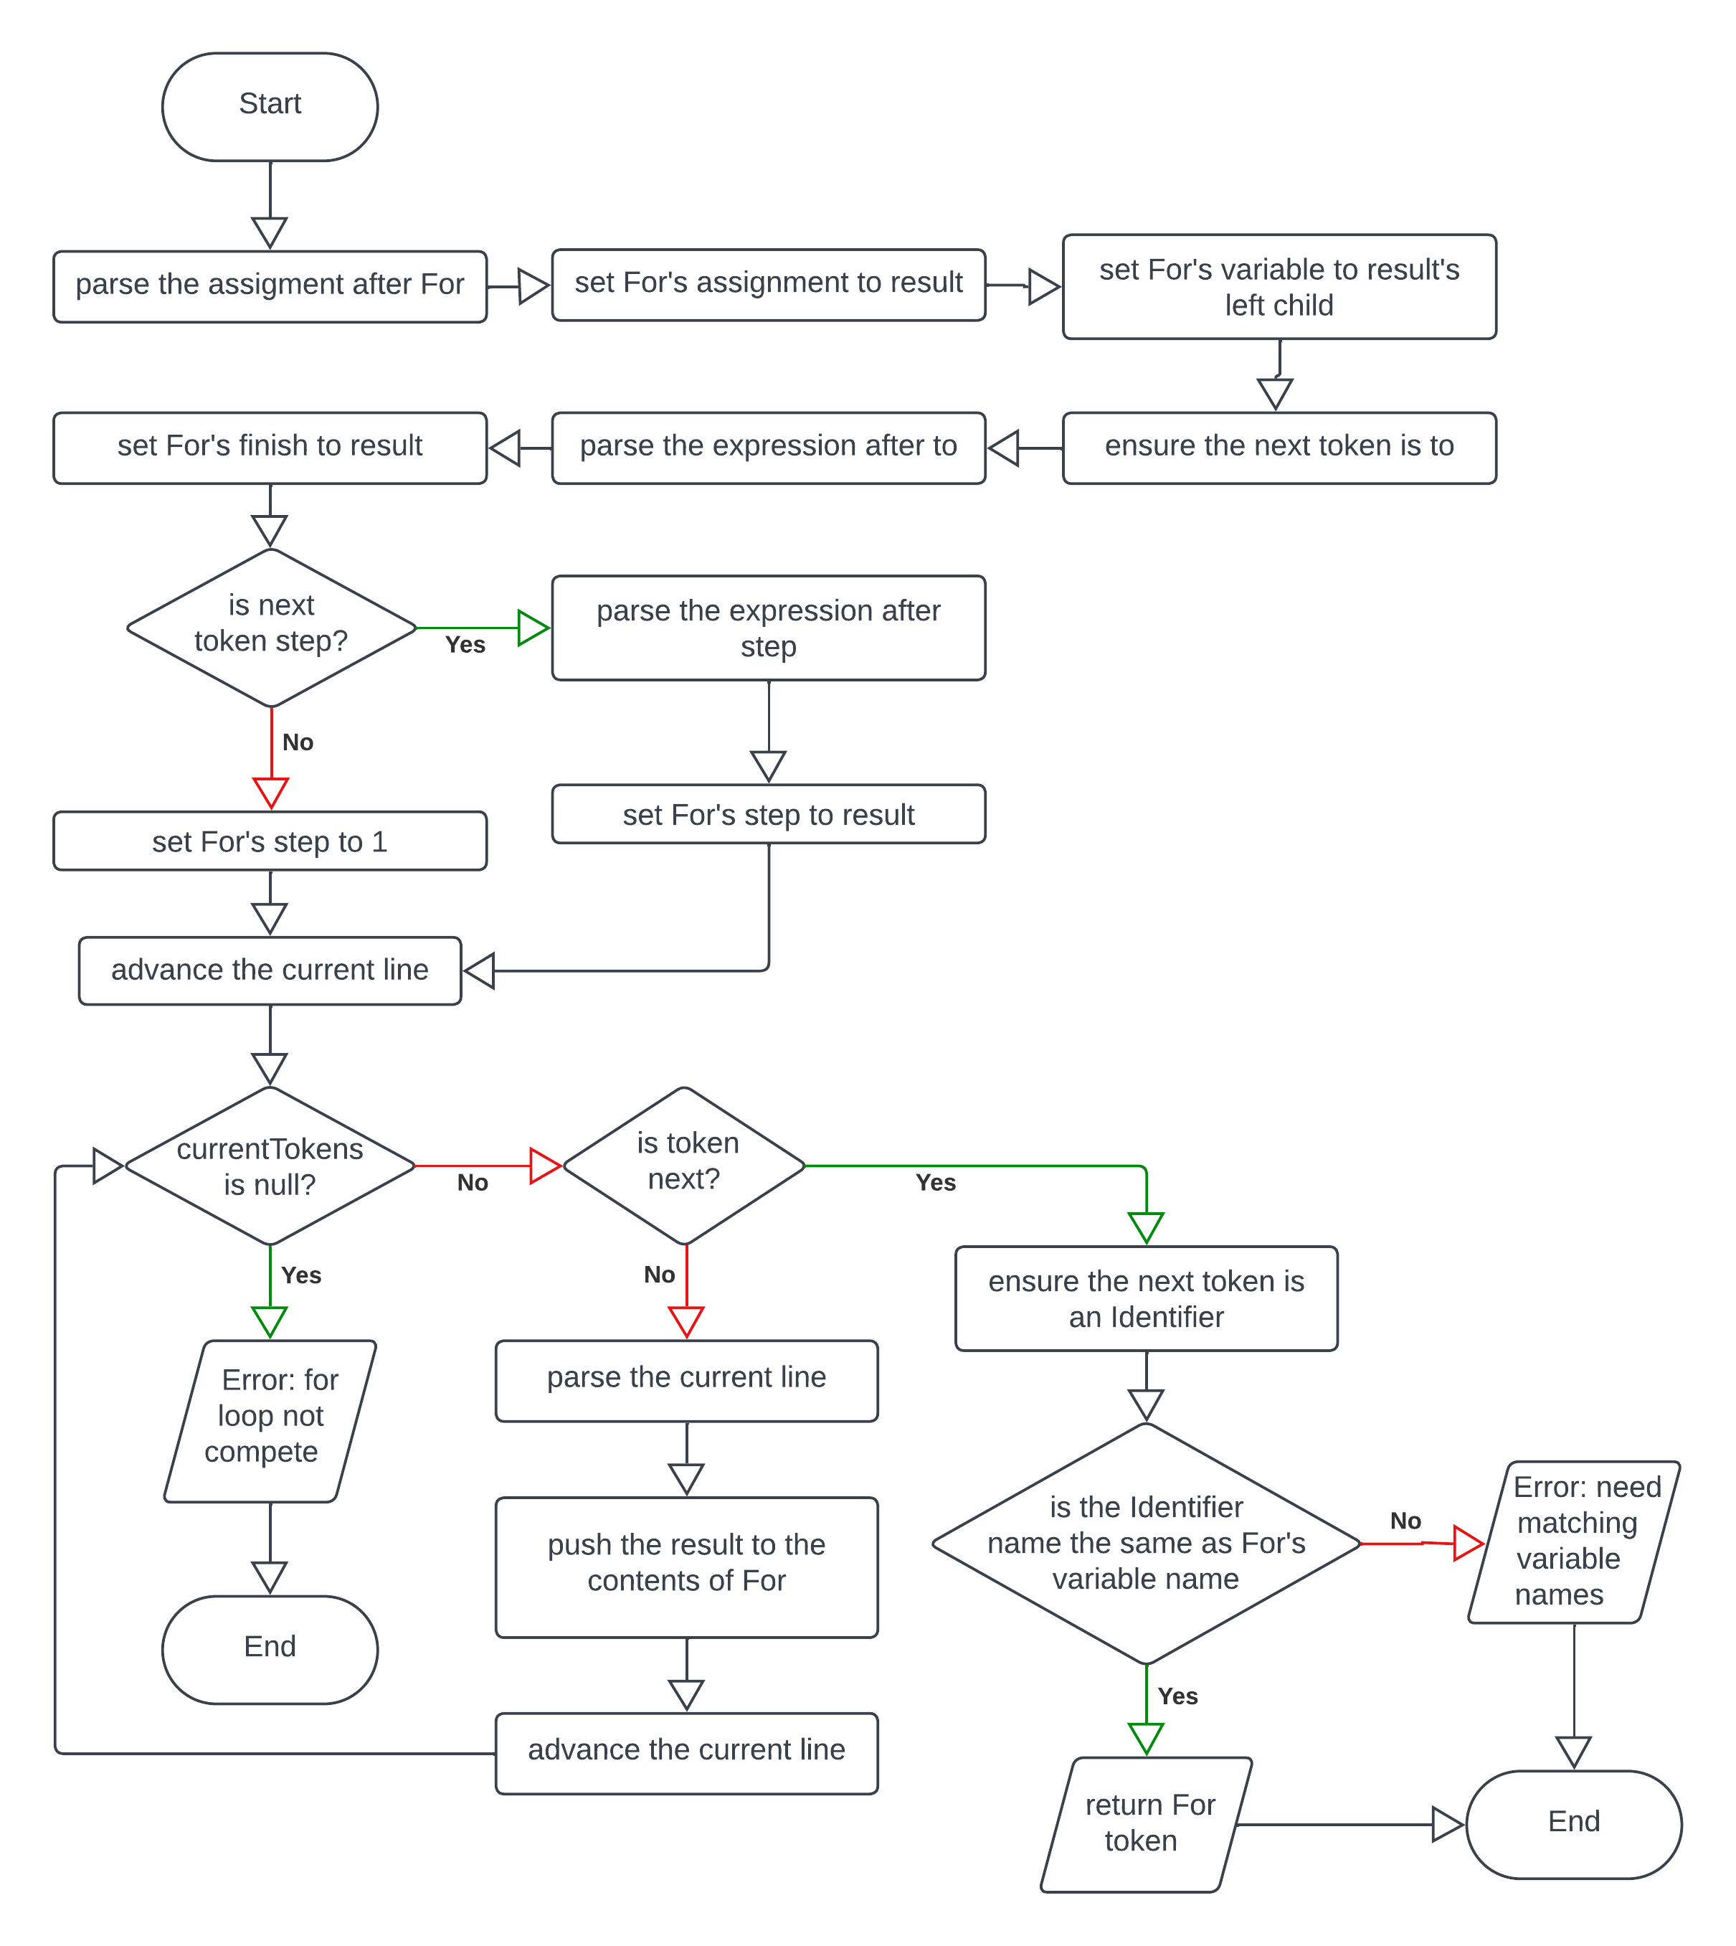The flowchart for this method is as shown:

This shows how long the algorithm is going to be, mainly due to the parsing of the first line. This is because every possible invalid input will have to be considered, so there will have to be lots of checking if the current token is null and if the current token is what it is meant to be: therefore, significantly increasing the size of the method, however it won’t be very technically complicated.

### integer checks

Finally, due to the way floats round weirdly in computer science, I would like to avoid using float values within the For loops. This is good programming practice and is important for the students to understand, as floats can lead to some weird and unexpected cases, Therefore, a check when evaluate_condition() is called for the first time should take place, and an Error should be returned. I’m planning to introduce a new error type called TypeError, however I will plan in more detail when I approach the issue.

# development: for loops

### A screen shot of a computer program Description automatically generatedbasic changes

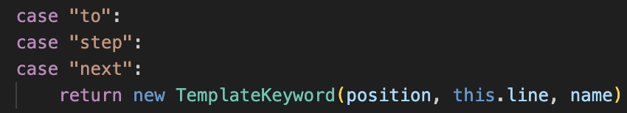This is my first attempt at implementing the For class

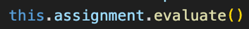I will return to it later, as I did not realise the evaluate_condition() does not work at all, but I cannot debug it until the parsing is completed and I can run some actual test cases.

The issue is mainly that I forget I am using my custom data types rather than JavaScript ones, so I need to use the value property.

### build_for_loop()

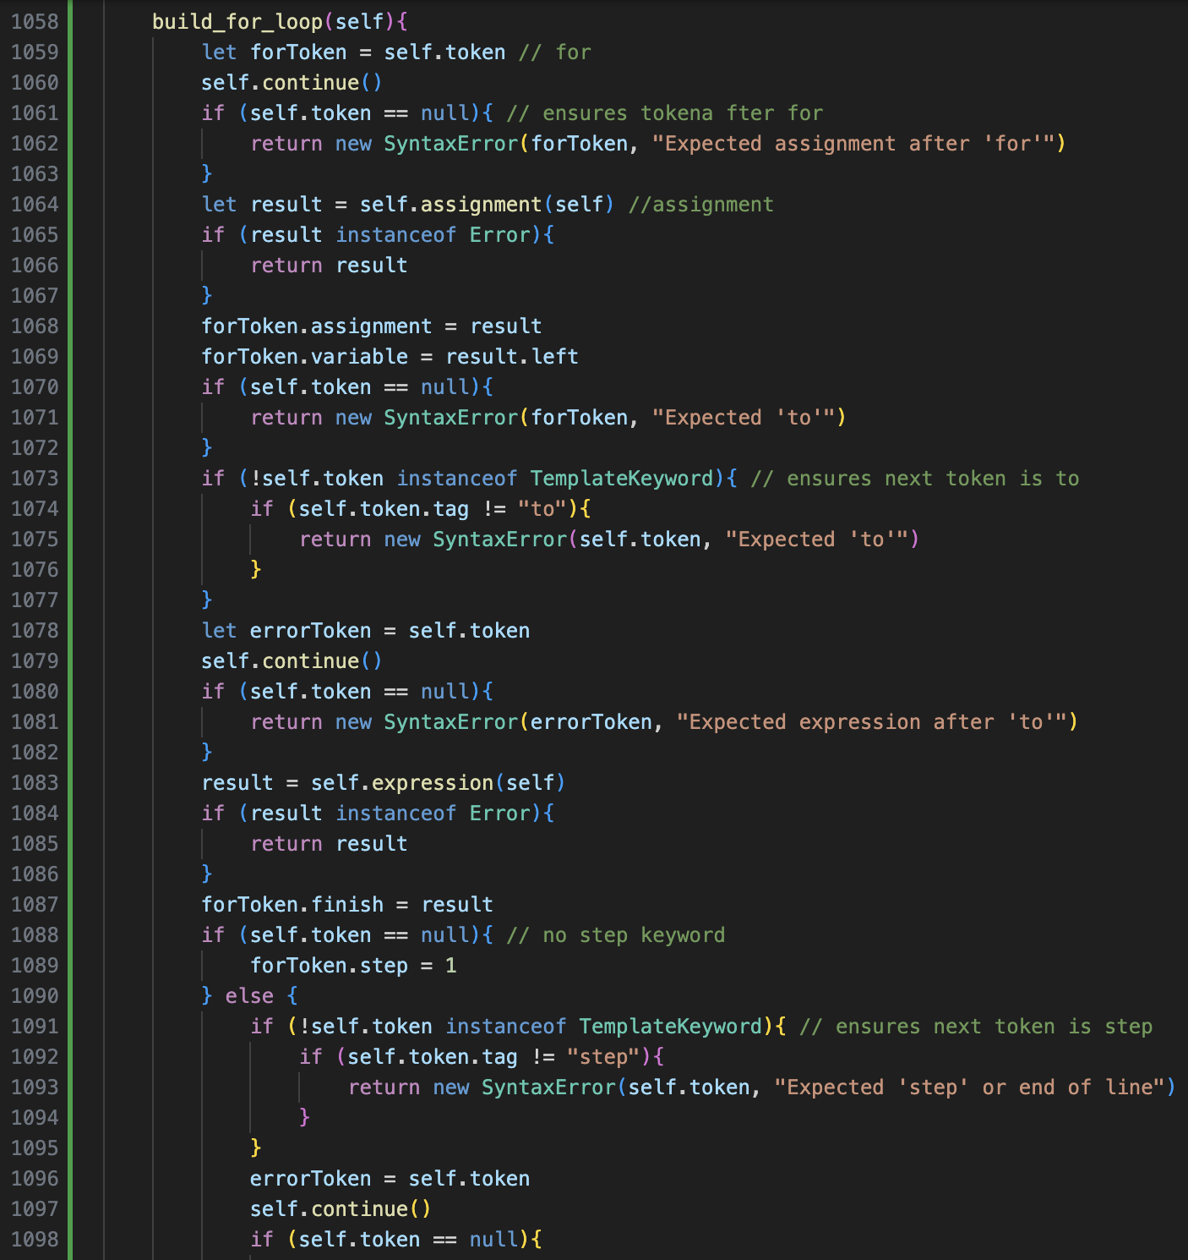In my initial attempt, I tried to implement as much error handling as I could, based off what I had learnt from building the previous loops.

The size of the method is so huge that it spans across two screens. This could potentially mean that it needs to be subdivided further, but I do not feel that Is necessary as it is just a long sequence of checks so it doesn’t make it much simpler from that approach.

I’ve ensured that I comment the important elements to distinguish the order that the first line is parsed.

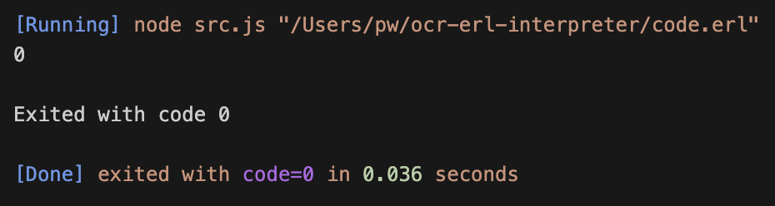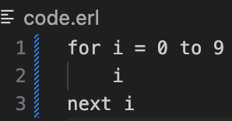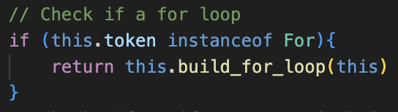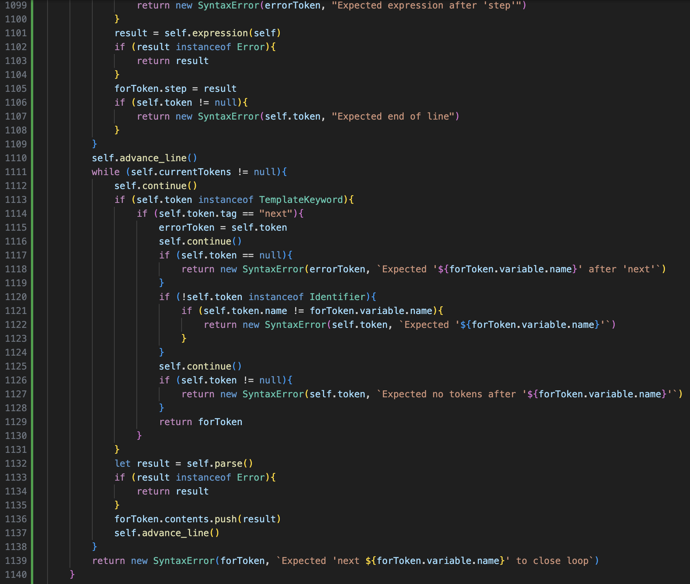After adding the check in parse() to call the method it is then complete.

However, when attempting to run this code, an incorrect error occurred. However, because the program did not crash, it was a good sign that the parsing had worked correctly, and that the issue was with the evaluation.

### A black background with white text Description automatically generatedA black background with white text Description automatically generatedevaluation fix

When I realise that I needed to use my custom data types, I changed the value that the variable is set to be an Integer, and for its value to be the value of its old evaluate method, plus the step value. However, this still did not work.

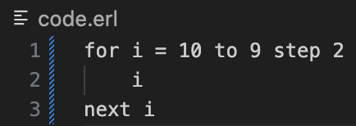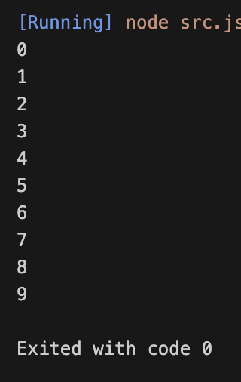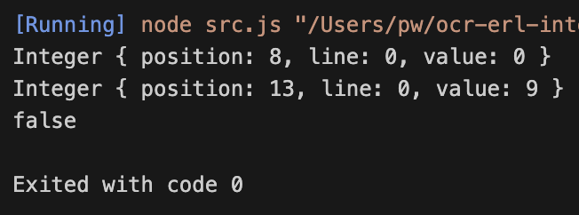After some debugging, the return statement also must be changed, to compare the value property of finish, and the value of evaluate(), and then the intended result was outputted, as shown.

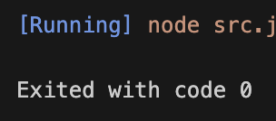When testing step for the first time it was also broken, however this was due to the same issue: the variable was being incremented by this.step, not this.step.value.

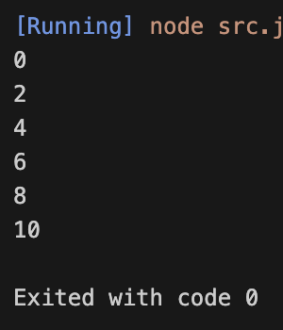

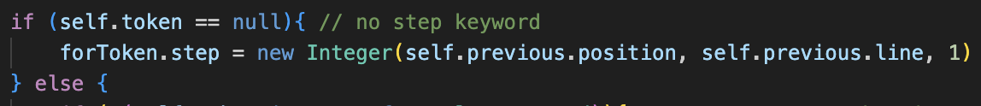Finally, the default step value set in build_for_loop() needs to be changed to a custom Integer data type with value one in order for this to work.

Potentially setting position and null might be a better idea, but largely doesn’t matter as does not affect the program in any meaningful way.

## error handling

There is a lot to test here, so I have split it into different sections.

### incomplete inputs in the first line

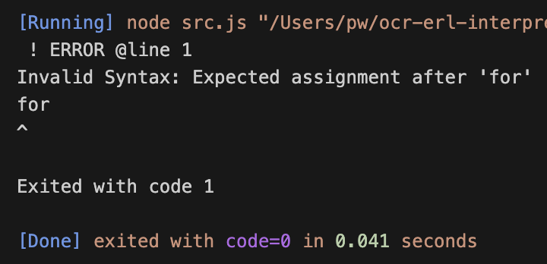🡺 **Just for keyword**

Correctly handles this.

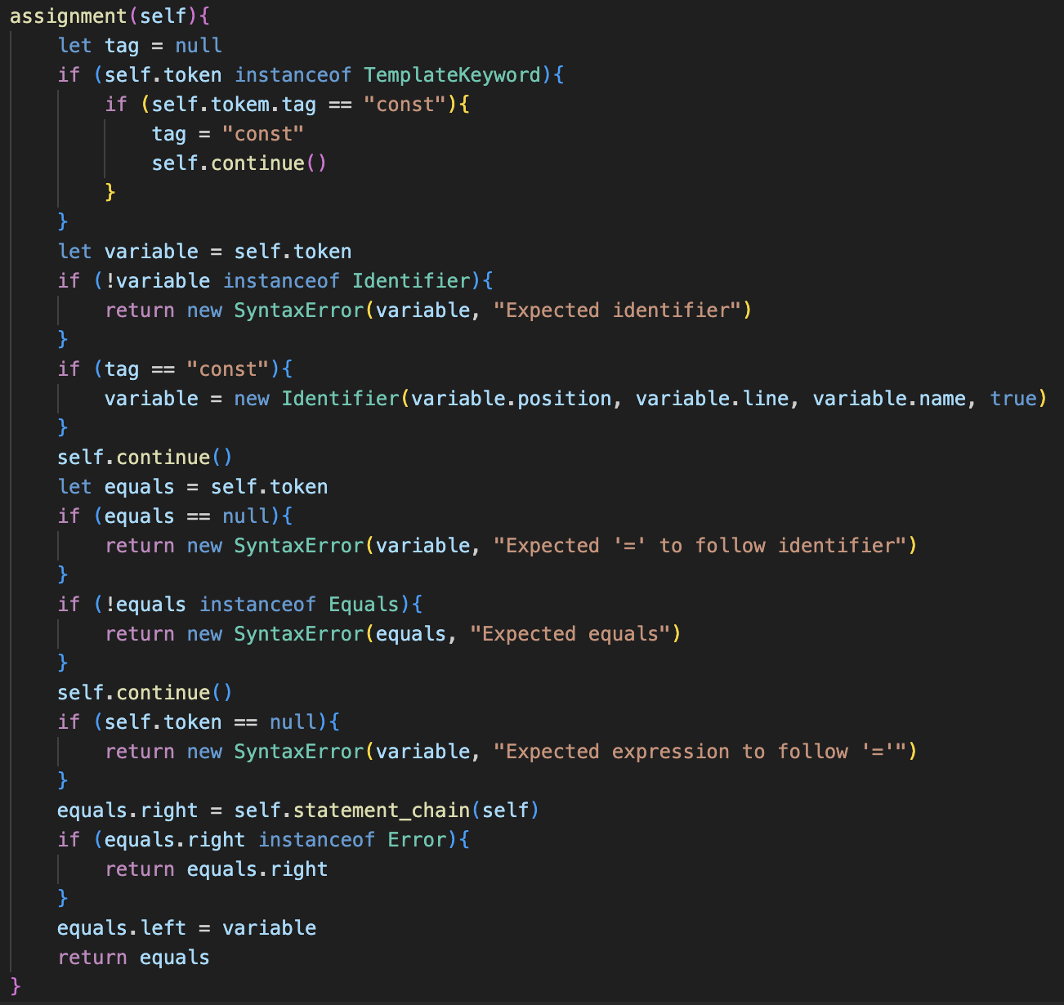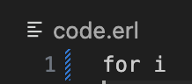🡺 **Incomplete assignment**

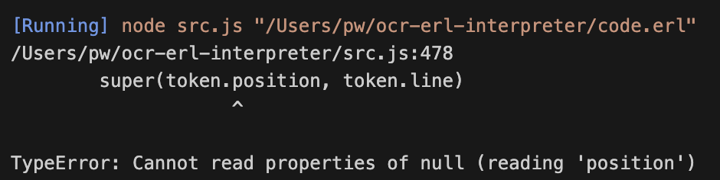This causes the program to crash.

This is due to the way assignment() is defined, as it currently has no error handling for the first stages, because prior to this it was only ever called when parse() detected an Equals as the second token in the stream, so therefore checking if an Equals was present was redundant.

I therefore redefined assignment() to include error handling for not having an Identifier or Equals or Expression, as well as more null token checks, so that any incomplete assignment errors are returned to build_for_loop()

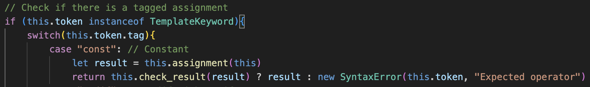I also removed the tag parameter and instead checked for a tag in the method itself, as it makes it fully self-contained, and it is a more logical place for it to occur.

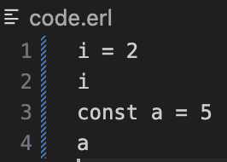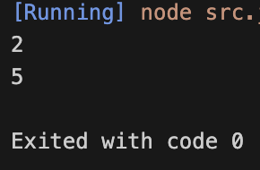Therefore, parse() also needs to be updated for the “const” call, so that it no longer passes the tag as a parameter which significantly simplifies and increases how easy it is to read the code.

Just to ensure that it still functions correctly, I ran a few tests with them used as normal assignments (with an example on the left) and they still worked as intended.

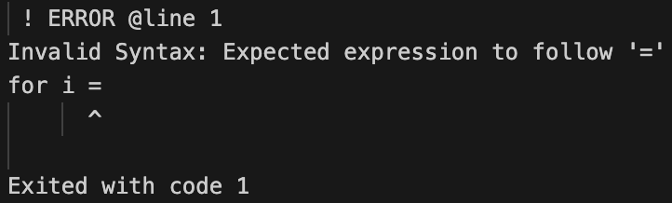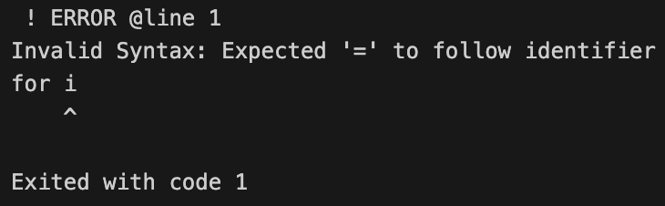However, this now also expands error handling for For loops:

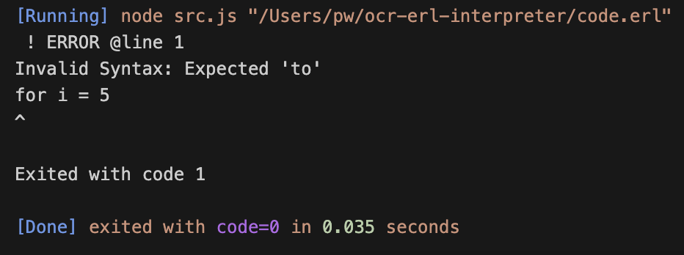**🡺 No “to” after assignment.**

Technically, this error is caught, however the pointer for location is completely unrepresentative of the issue. This has also been a problem in other Error messages: where they point to the initial Token of the structure rather than the point that is relevant to the Error.

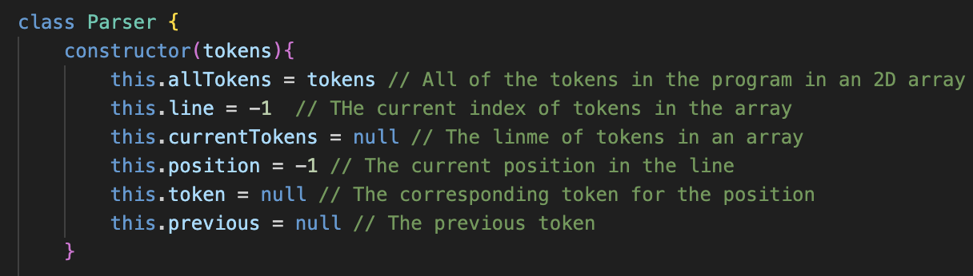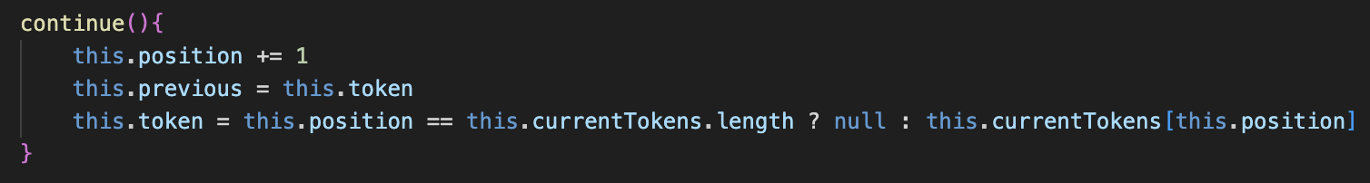Therefore, I feel like a new feature is needed to fix this.

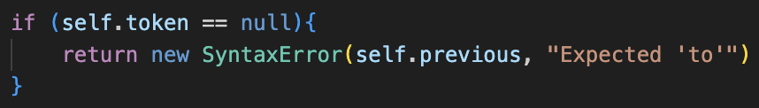The solution is to add a new property to the parser, called previous,

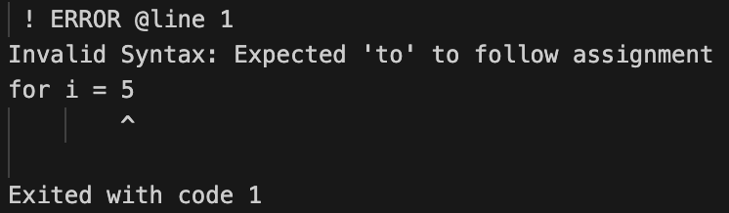This will be updated in continue() and will always hold the value of the previous token. It can therefore be passed as the token in Error messages and much more accurately points to the error.

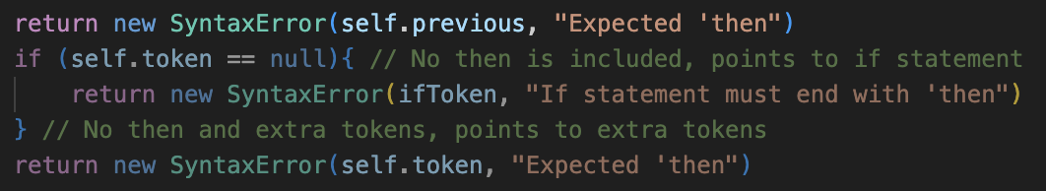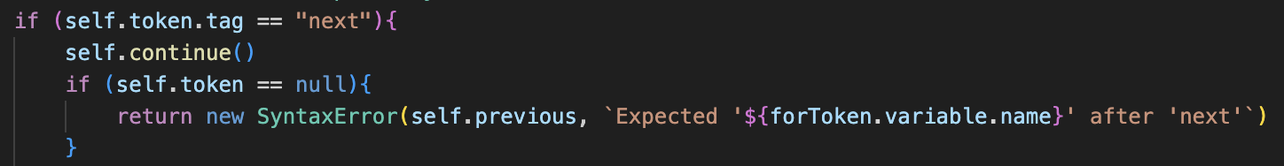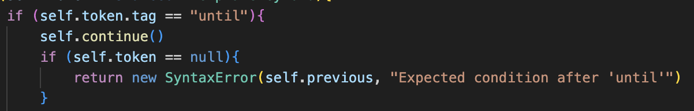As show, this error message is now much more useful for the user, as it more precisely points to the issue. This can also be used in the other build methods:

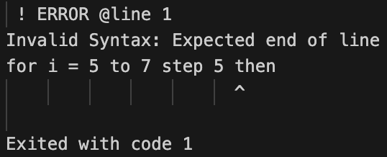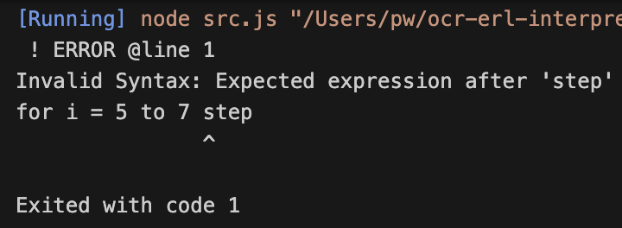🡺 **“step” related errors**

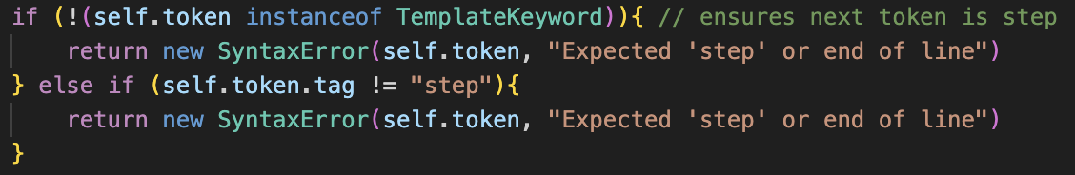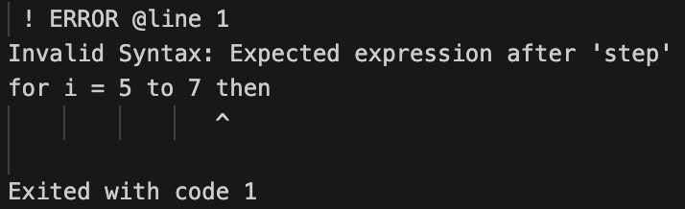The code for checking if a token other than step was present was incorrect: this new updated version has some repeated code but it is the only way as otherwise the tag property may be called for a token that does not have the tag property.

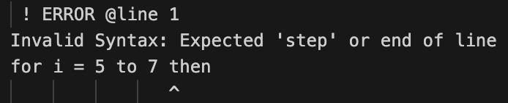This now correctly functions:

Now every possible case for the first line of code has correct error handling.

### A screen shot of a computer Description automatically generatedA screen shot of a computer Description automatically generatedclosing line errors

🡺 **No closing statement or lone “next”**

**🡺 Incorrect variable name**

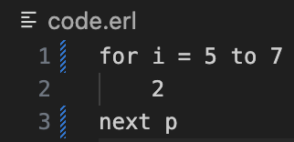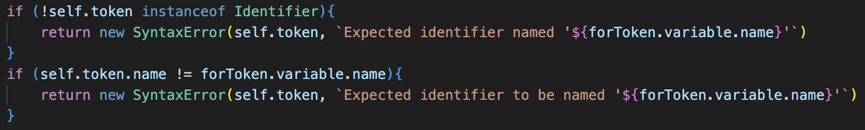

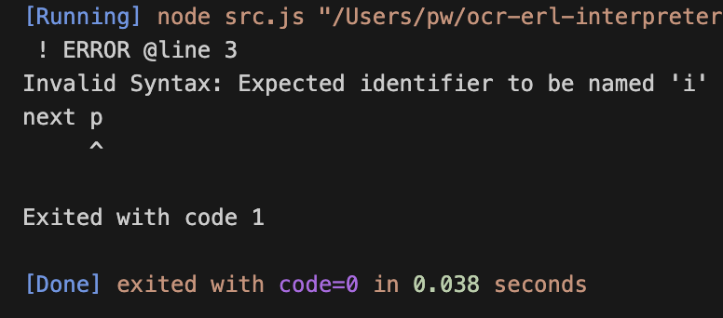On the first test, it outputted as if it was a normal loop, but that was because I had put the name checking if statement within the Identifier checking one, so after separating them out as shown it worked as expected.

## integers only

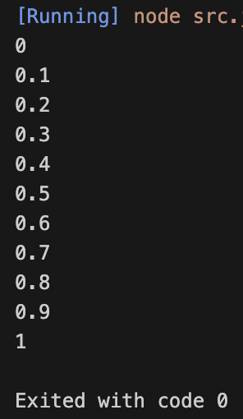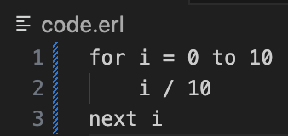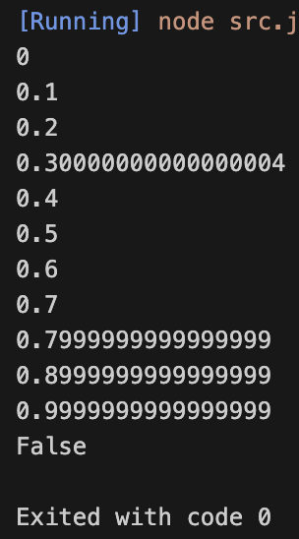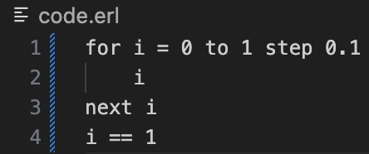As briefly described in the design stage, I feel as if it would be good to remove the ability to use floats within for loops, because of the really unexpected results they make, due to the odd behaviour when adding together floats. A for loop should always end with the final value and as shown in this example, using floats does not mean this is always true.

The much better approach, which should be used, is the one on the left to produce more accurate results.

Note for some reason, the Divide evaluate() method previously returned its two children multiplied, which had to be fixed.

### type error

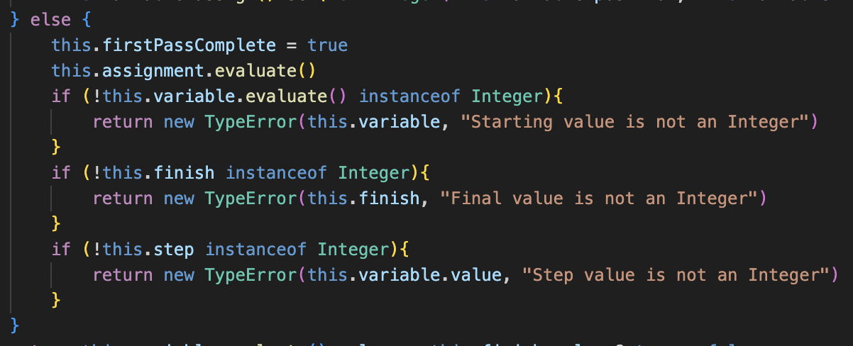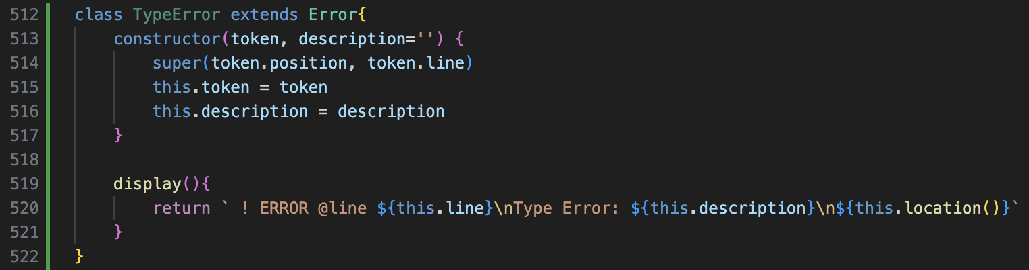This will be the Error for data-type related issues and will be used significantly in the next module of code, but for now it is a basic copy of the other Errors.

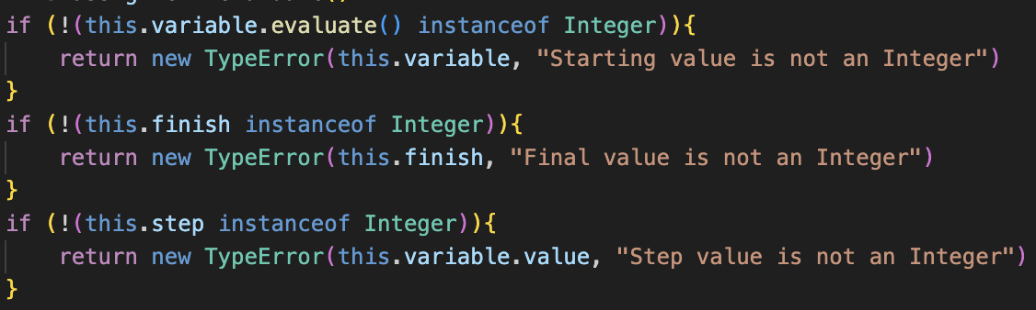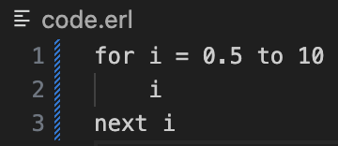From here, when the loop is evaluated for the first time, so when firstPassComplete is false, the checks will run to ensure the starting value, final value and step are all integers, and a TypeError will be returned if this is not the case.

When testing this, it did not catch the error and the loop executed using the float values, which was confusing.

However, it turned out to be due to the order of operations: with brackets being required as ! has higher precedence than instanceof. I’m sure I’ve had this issue previously in this project, but it still caught me out, and when searching the program for other occasions on this error there were 9 more, which I fixed so they would work as I intended.

### error messages

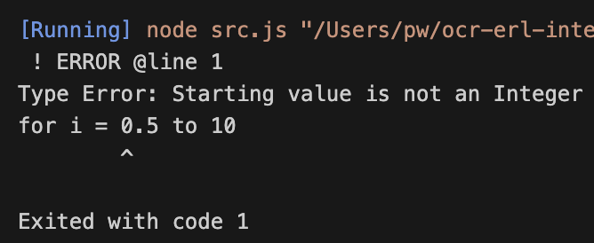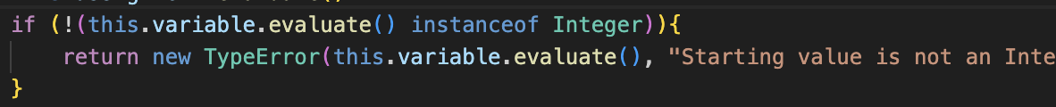Initially the starting value not being an Integer pointed to the Identifier, so I changed it to point at the value, and then the correct error message was returned.

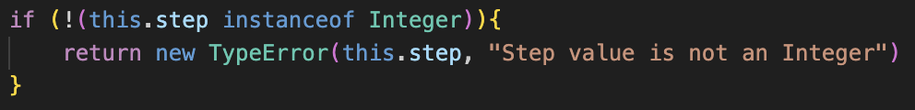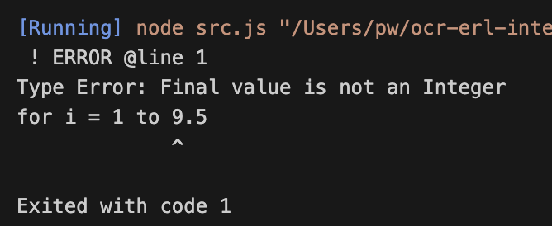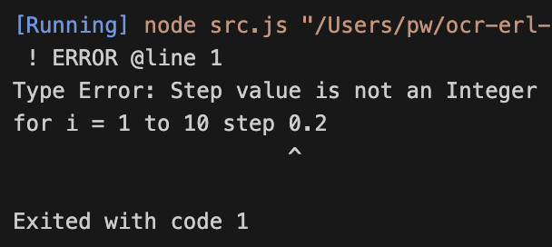The step error check also had to be changed to point to the step rather than the variable value (which it was for some reason), but after that all the error messages were correct.

## negative step for loops

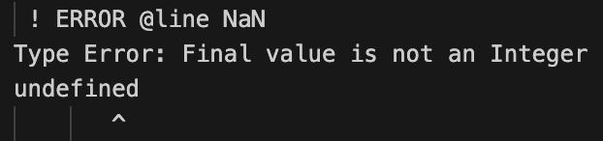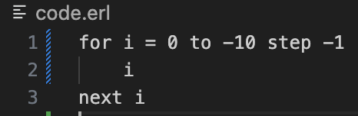Currently when attempting to run a for loop with a negative step, the program returns a weird error to do with non-integer values.

My initial thought is that this was to do with how my program dealt with negative numbers in factor(): it would return a Minus token, with zero on the left and the right being the value.

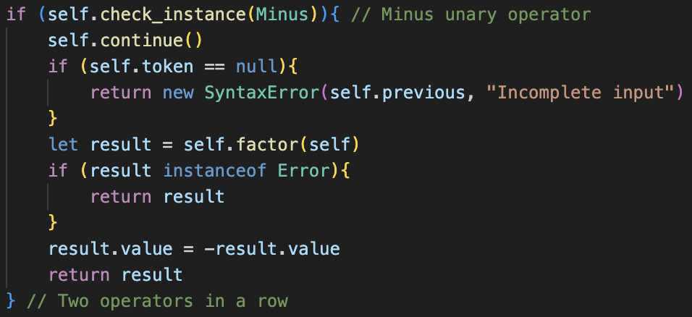Therefore, when checking if the value is an Integer, it sees the Minus token and therefore thinks that it is not, so this system needs to be updated. This needs to be done anyway as it is not a very efficient method.

Now, the program directly modifies the value of the token, which also improves memory and therefore performance. I also changed it to use the new previous attribute, rather than saving an errorToken.

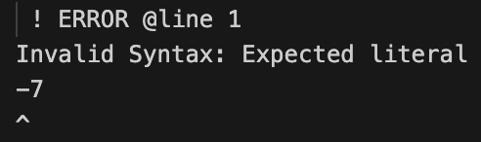When running a test, this worked when the negative numbers were in the middle of an expression, but the expression could not start with a negative number.

### fixing starting negatives

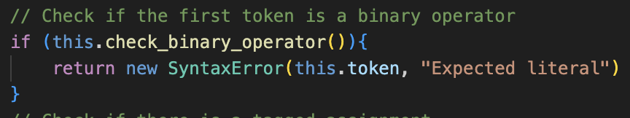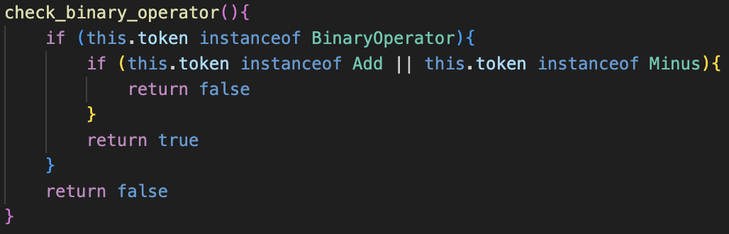This is due to the check for binary operators in parse() and statement(), to ensure that the current token is not something like a * which would crash the program. However, this should not be the case if it is Add or Minus. Therefore. A new method will be added to check this, to reduce code repetition across methods.

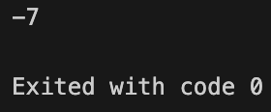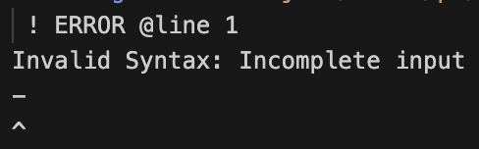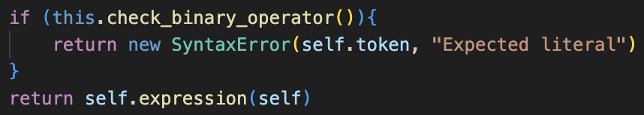This was then called in parse() and half_statement() to replace the old checks for Binary Operators.

Now the line can start with negative numbers, or numbers beginning with positive signs, and single Plus or Minus operators still cause errors, ensuring that the program does not crash.

### updating for loop checks

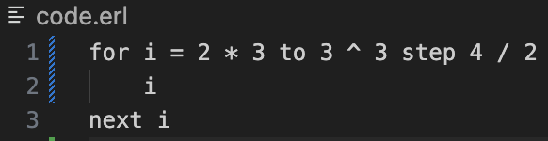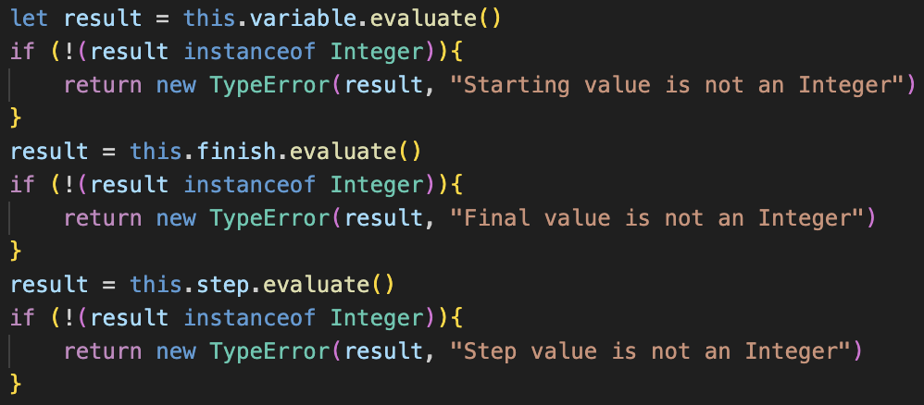Even though negative can be used by themselves now, any expression that was in any of the parameters would not pass the Integer check, because I must call evaluate() to get the result, and then check if that is an Integer. However, the test case outputted nothing.

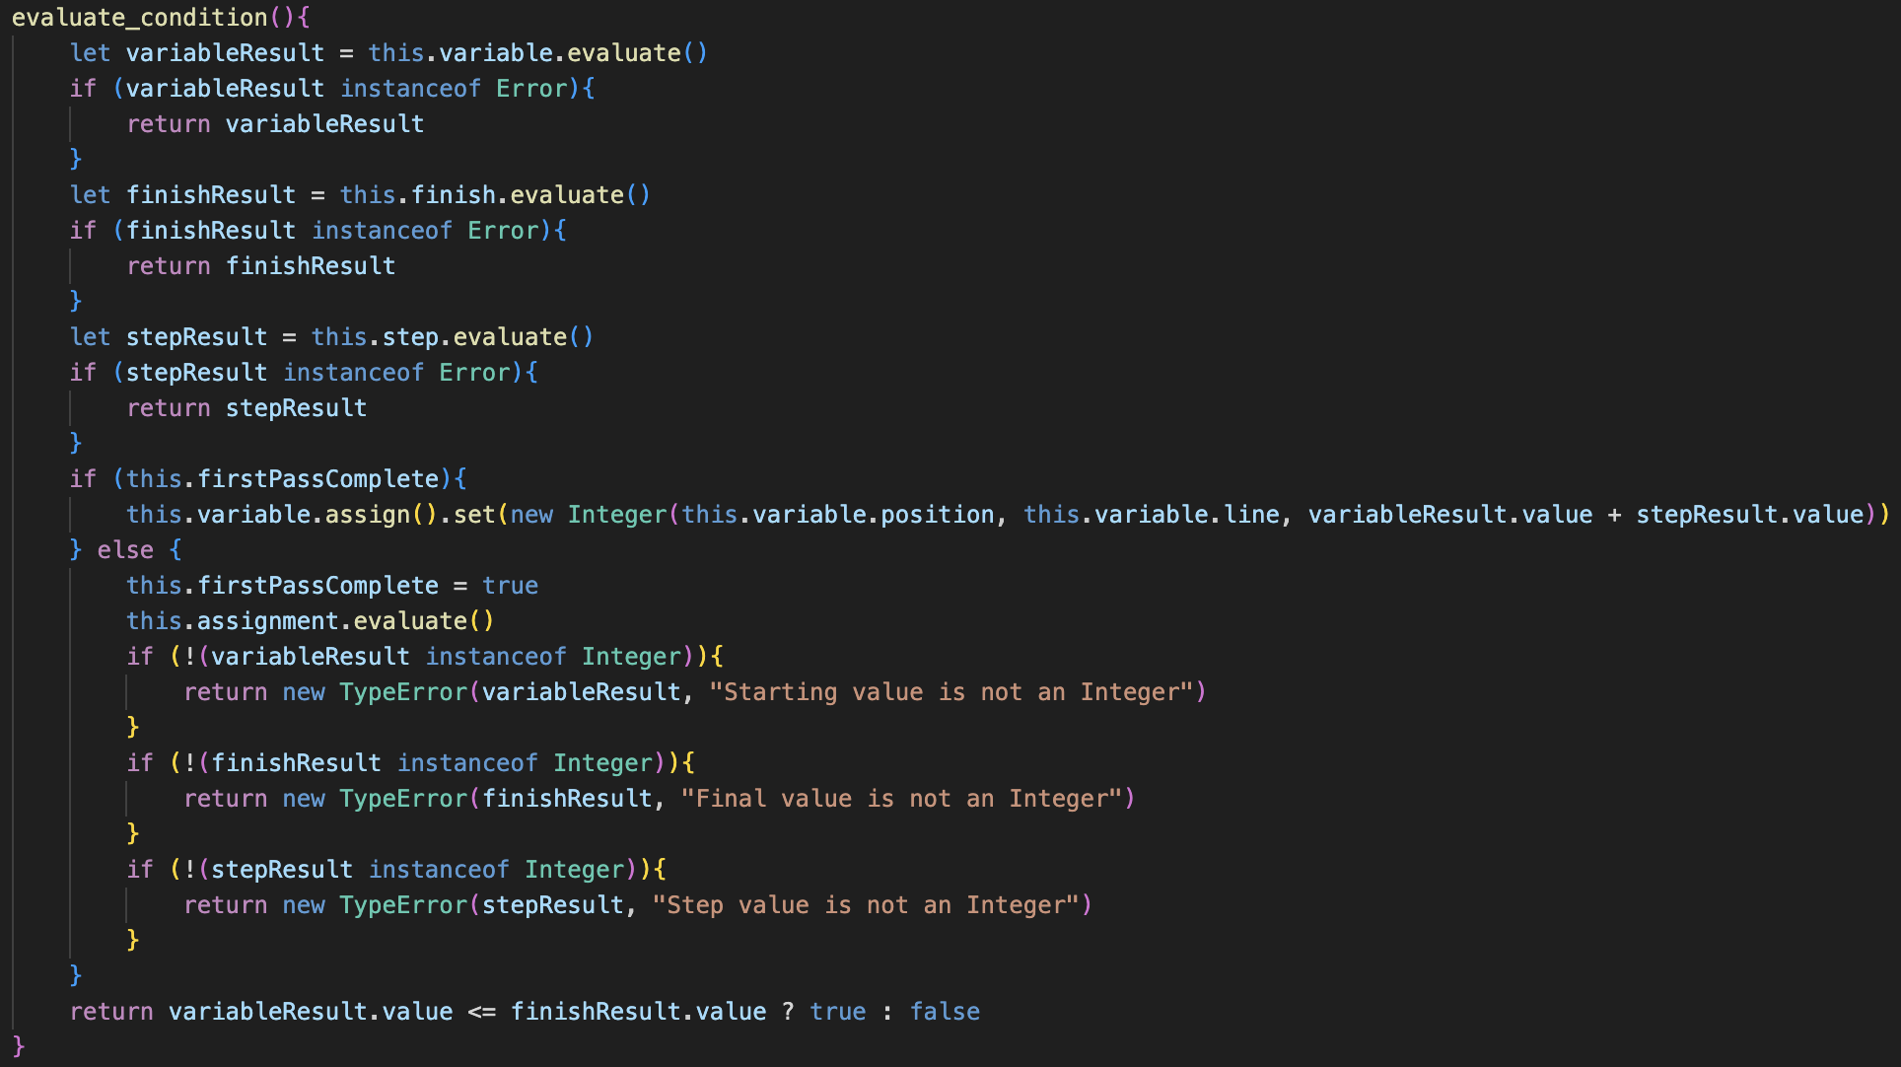This was because the final return statement and the setting statement both treated variable, finish, and step as if they were Integers and therefore did not call evaluate() as they could potentially be asts.

In order to minimise calling, evaluate() as much as possible, evaluate_condition() now sets the result of the 3 evaluate() calls to variables and ensures they are not errors. Now, the rest of the method uses those variables instead of the attributes themselves, using their value to change the variable value; using them to check for Integers; comparing their values for the return value of the method.

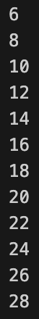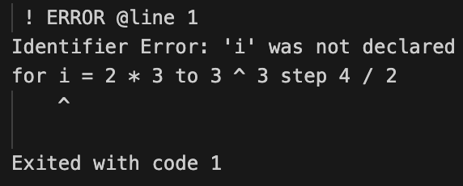It is important to not call evaluate() multiple times as in the future there may potentially be input() calls within the evaluate() calls, so if evaluate() is called multiple times it could prompt multiple input calls when there should be a single input which would cause issues.

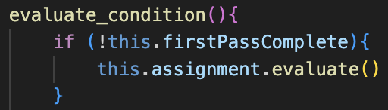This issue now occurs because variable.evaluate() is called before evaluating the assignment to give it value.

This requires this little check at the start of the program, but the Integer checks and setting firstPassComplete to true still occur later in the program where they used to, only moving the assignment evaluation up.

Now expressions can be used in For loops, as well as negative numbers.

### A black screen with white text Description automatically generatedupdating conditions

The issue with the current system is that a for loop which includes variables in its parameters will have constantly changing finish values. For example, the for loop on the left will continually output increasing numbers, as its finish condition keeps changing. I’m not currently sure if I want this in my program, as the other option is taking the initial values of the finish and step and storing and using them.

When asking my stakeholder Tanish, he said that:

*🡺 “I don’t think it’s good practice to change the loop condition variable within the for loop, so it’s best to exclude it as it is for kids to learn coding in school. You could then also have cases like for i = 0 to i + 2 or something, which look weird and would result in this infinite loop thing, so I think you should take the starting values and keep those, and base the program of that, kind of like python’s range feature”*

I agree with this idea, so will change evaluate_condition() to reflect this new method, he then also then pointed out a second issue:

*🡺 “Should the variable that the for loop is iterating through be able to change? As in, I know you can change it, but when one iteration ends should one be added to that new value, or should it be reverted to the old value and one added to that? I think python would do the second option but the range method is different to traditional for loops so I’m not sure which one in this case would be best.”*

Although I think changing the value is bad practice, I think it would be difficult to implement a system to completely block changing the value. My worry then is that infinite loops could be created if something along the lines of i = i – 1 was included within the loop, and there would be no stop. Therefore, a python like approach where the value of the iterated variable is forcefully set to the expected next value would be best and cause less cases where infinite loops could occur.

*🡺 “Yeah, that sounds like the right idea.”*

So, with this, a redesign of evaluate_condition() is definitely needed, as these changes are going to need a new system to implement them.

### new system

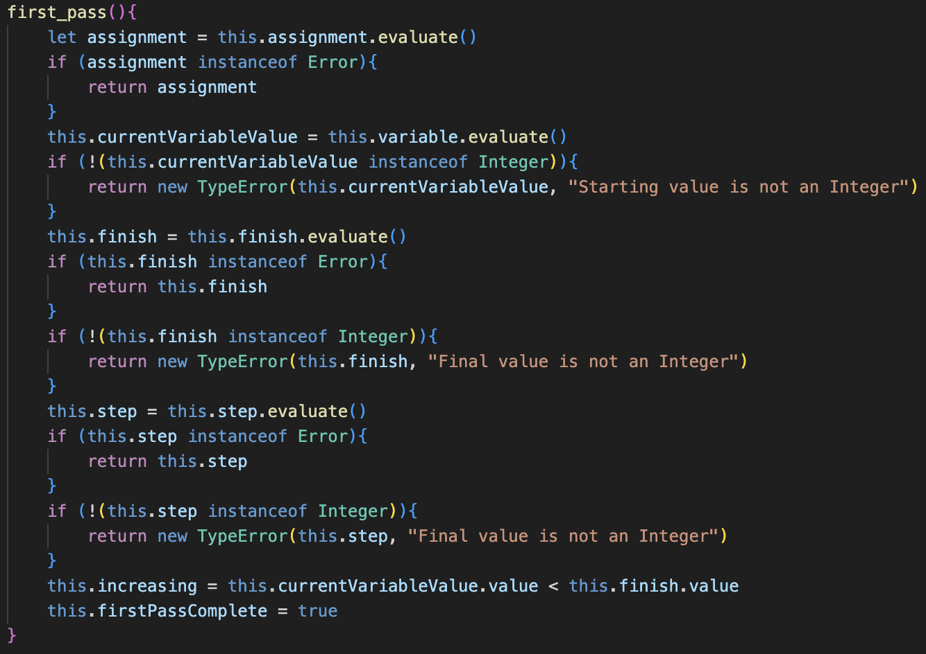The new system has a separate method for the first pass, to increase readability. As well as increased error checking, this now sets this.finish and this.step to the result of their initial evaluate() call, and they stay as that for the rest of the program, so any changes in variable do not affect them.

The value of the variable is set as currentVariableValue, a new property. this.variable is kept so its value can be updated at the start of each cycle, but currentVariableValue represents its value for the object, so any changes to the variable don’t affect the loop.

Finally, an increasing property is added, based off whether the loop will be increasing or decreasing, but this will go into more detail later as it currently requires more case handling.

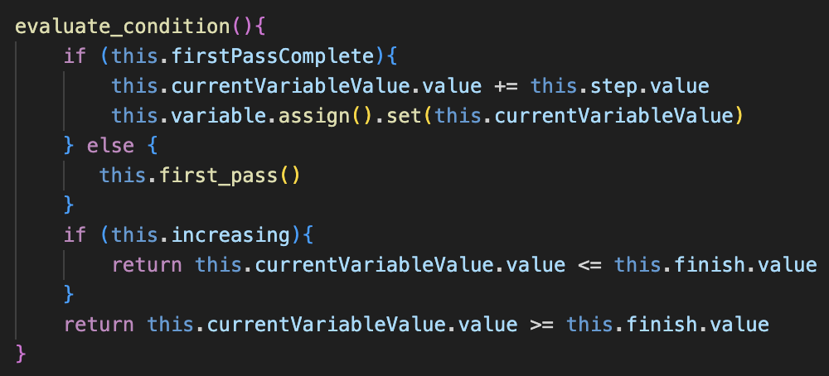So, when not the first pass, the value of the currentVariableValue will be incremented by the step value, and then the variable will be assigned this as its new value so it can be used in the program. This means that if the value of variable is changed, it will not affect the loop at all, as it is completely based on current which cannot be changed in the code.

Finally, if increasing is true or false decides which comparator is used.

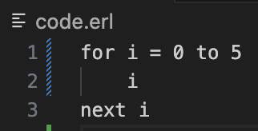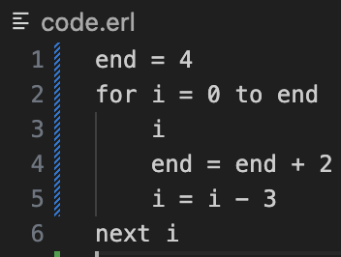The test cases show that this new method still allows normal for loops to occur, but the one on the right also shows that the value of i is reset to its actual value after each iteration, and that the initial values of the loop are what affects the condition: the final value is the same

### negative step

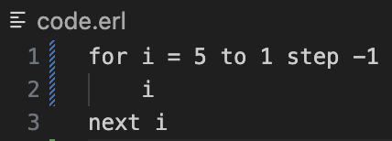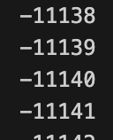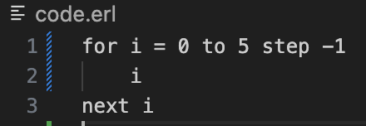With this new system, negative step now works due to the new increasing property, however some new cases are required when the step is negative but the bounds are not and vice versa, to ensure no crashes occur for.

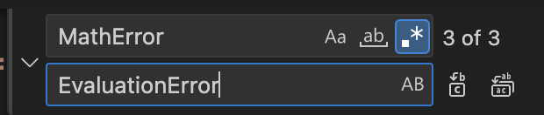For this, I have decided to rename MathError to EvaluationError, as MathError was too specific and I need a more generic Error for issues that occur when the program is evaluating, which is different from syntax or type errors.  
I also updated the error message to describe this type of error more accurately.

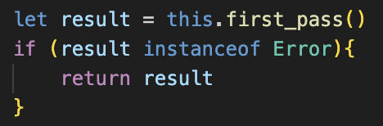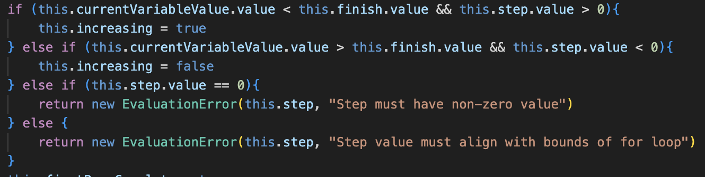Therefore, at the end of first_pass(), this check occurs, and if the step and bounds do not align, an EvaluationError will be returned. Additionally, a check that the step is not zero is added as this should not be permitted.

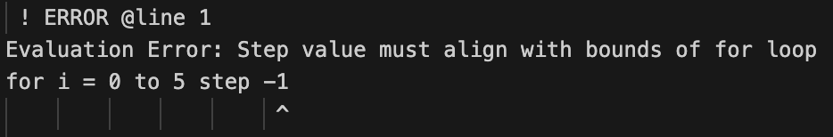This should have been added earlier, but a check needs to also be added in evaluate_condition(), so that if first_pass() returns an Error, it is returned.

Now, this is correctly handled, and For loops are decently robust now: more testing will be needed but I am happy with their current state.

### large issues

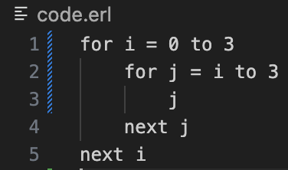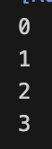Whenever nested loops are involved, the entire system breaks down. This is very similar to the other loops and if statements, and the entire run() has not been built very robustly so requires a full redesign.

So, work on for loops is complete for now, however I am now adding an extra stage in order to redesign the interpreter.

# design: changing the run system

Currently, I feel like there are two main issues with the system. The first is that there are loops being combined with return statements in the same method, which leads to a lot of errors. Secondly, different evaluation methods return different things: sometimes asts, or tokens or 0/1. There is no consistency which leads to a lot of issues, so this needs to be fixed.

**🡺** evaluate_single_ast()

This is the main method for evaluation and will take a single ast as an input, containing the contents within the loop of the old evaluate_asts(), but with no iteration to avoid conflict between loops and using return. It will have the same checks as always but will be made to only ever return 0 and 1, and when loops and if statements are encountered, their corresponding methods will always return 0 or 1, so it will check any calls, and if the response is 1 then it will return 1.

🡺 evaluate_many_asts()

This method contains a loop that will call evaluate_single_ast() until it has iterated through all the asts in its parameter. Each time, it will check if the value it gets back is 1, if it is, it will return 1, and will otherwise return 0 after all the asts have been iterated through.

🡺 evaluate_loop()

Very similar to previous, but will only return 0 or 1. Therefore, if the condition is an Error, it will not return the Error and will instead output it in that method and then return 1. Otherwise, it is very similar, also checking each time it calls evaluate_many_asts() to see if it has been returned 1, where it will also return 1.

🡺 run()

The same as always, now calling evaluate_single_ast() each time it calls parse_next().

Hopefully, this should deal with a lot of the issues previously had.

# A screen shot of a computer code Description automatically generatedA screen shot of a computer code Description automatically generatedA screen shot of a computer program Description automatically generatedA screen shot of a computer code Description automatically generateddevelopment: changing the run system

This was my first attempt at adding these changes.

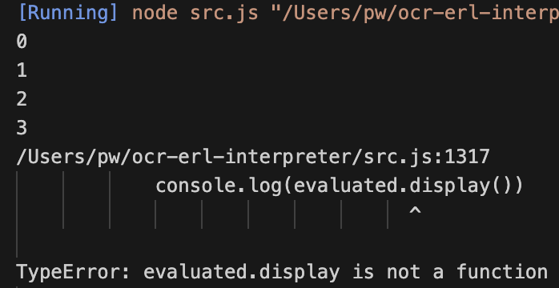When running the same script as earlier, instead of just stopping, the program now crashes: which is a good sign as it shows where progress can be made. It seems as if something is being evaluated which should not have been, so some debugging is required.

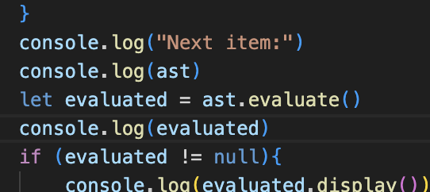Initially when printing the value of evaluated, it showed an Identifier within an array, so I removed the now redundant array check in evaluate_many_asts().

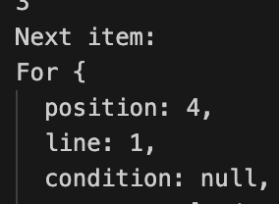However, when doing further outputs, somehow a For loop had got to the evaluate() call within evaluate_single_ast(), instead of being caught within the for Loop.

This was because, in the Loop catch, if 0 was returned by evaluate_loop(), it would continue rather than being returned, and would therefore continue to be evaluated and attempted to be displayed.

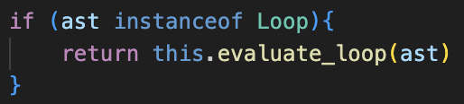This was a very easy change and shows the benefit of separating the recursion and returns, and now the program no longer crashed, but still prematurely stopped the counter after printing the first 3.

### loop issues

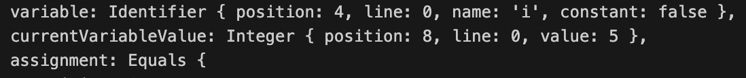I then decided to do some debugging in evaluate_loop() as this was likely the source of the error.

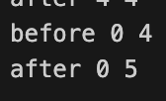When outputting the main For token at the end of the first nested loop, somehow the value of its currentVariableValue had increased when it wasn’t supposed to.

To confirm this, I made evaluate_condition() output the position of the For loop (to distinguish the two) and the before and after values of currentVariableValue.value before and after it was set, and somehow the main For loops had started at 4, the final value of the nested one.

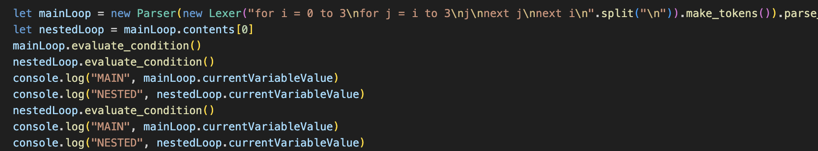Somehow, whenever the nested For loop was incremented, it also changed the value of the main For loop, even though they should be two completely different properties.

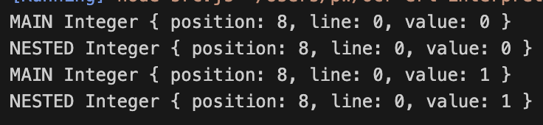Even when manually calling each method, the same result still occurred.

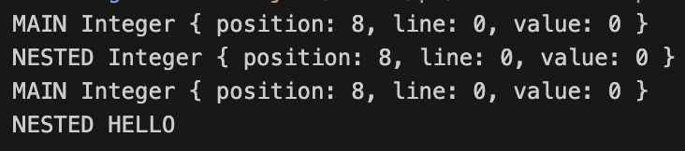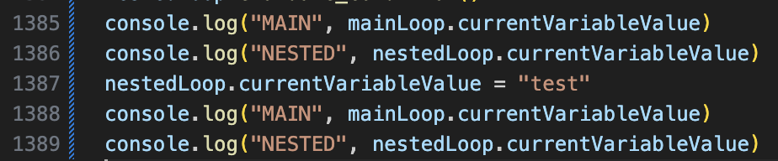However, manually changing one didn’t affect the other.

### the solution

This meant they did not point to the same memory location, so therefore something was wrong with evaluate_condition() which caused both to be changed. After further debugging, I realised that it was not that currentVariableValue was the same property, it was that they both currently pointed to the same token in memory, so by changing one you change the other.

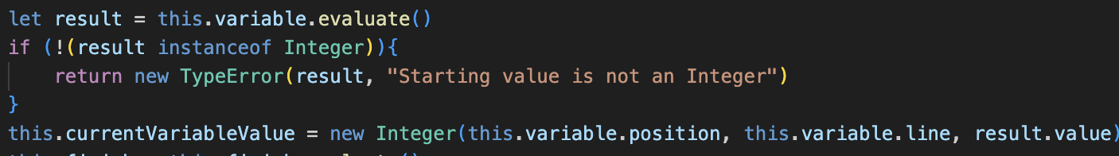This is because currentVariableValue of the main loop is set by calling evaluate() on the Identifier i, and for the nested loop it is set to j being set to the evaluate() of i, and that being evaluated. Somehow these two point to the same memory location, which must be JavaScript attempting to optimise memory as much as possible. Therefore, a new Integer instance must be created for currentVariableValue.

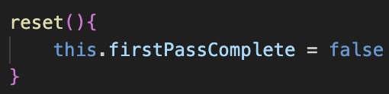My new solution is above, however I feel that the program will still not work as there is one more issue.

The nested loop’s values must be reset after each iteration, otherwise when the second iteration of the main loop begins the variable will not be back to the starting value. This can be easily added by setting firstPassComplete to false, which I do in a method called reset()

This must be called at the end of evaluate_loop(), before 0 is returned by the method.

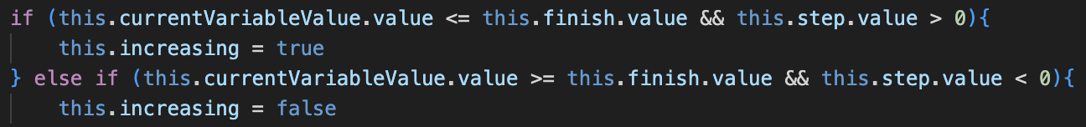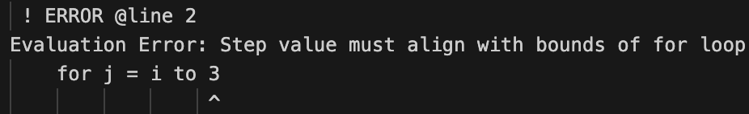When testing, the actual solution was almost returned, however the program returned an Error on the last input due to a bounds issue.

This just required the bounds check to be changed to allow the values to be equal.

Then, finally, the expected output was returned, which took a lot of attempts but now the new run system works as expected. Although a lot of this was due to issues not in run, the new Interpreter updated has also fixed a lot of other errors, including ones to do with If Statements, but the whole new system is a lot clearer and easier to understand and implement into for the future.

### A screenshot of a computer code Description automatically generatedchanging conditions

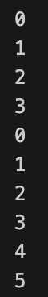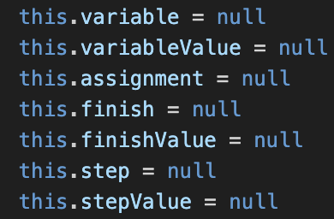Even though the bounds and step of the loop should not be able to be changed during the loop, after reset() is called any updated parameters should be affected. In this example, the loop should count to 5 on the second iteration, but instead it only counts to 3. This is because the property for end and step are completely replace by their evaluate() result, so their asts are destroyed so any changes are not updated. Therefore, we need separate properties for the asts and the properties when they are used.

This needs new properties: finishValue and stepValue, and currentVariableValue has been renamed to variableValue for consistency. finish and step hold the ASTs, and finishValue and stepValue hold the results of their evaluate() methods, which were previously set to themselves. This means a lot of code in first_pass() and evaluate_condition() must be updated to reflect these changes, but it allows the Parser to remain the same.

Now, the correct output is produced due to these new additions.

### other changes

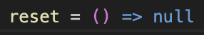Now a reset() method must be added to the other loops. For a Do loop, this is the same as For and it sets firstPassComplete to false. For While it just returns null.

Also, because For does not use the condition attribute, I changed it from being in Loop to being defined seperately in While and Do because having it in For is bad practice.

For now, this wraps up the work on Loops, and I will do more in-depth testing during the Half-way evaluation to ensure it is all working as expected.

# evaluation

|  |  |  |
| --- | --- | --- |
| No. | Criteria | Implemented? |
| 5.1 | Allow while loops to be created by “while”, then a condition, then the contents of the loop on the next line, and closed by the “endwhile” keyword | **Yes** |
| 5.2 | Ensure that the contents will be evaluated before the loop is run, and it will iterate while the condition is True | **Yes** |
| 5.3 | Allow a do until loop to be created by “do”, followed by the contents, and being closed by “until” then the condition of the loop | **Yes** |
| 5.4 | Ensure that the loop is run once before the condition is checked, and from there it iterates while the loop is False | **Yes** |
| 5.5 | Allow for loops to be created by “for”, then an identifier, then “=”, then a starting value or expression, then “to”, followed by a final value or expression. Then, the contents, closed by “next”, followed by the same identifier that the for loop was defined with | **Yes** |
| 5.6 | Ensure that, on each iteration, the variable with the identifier name is set to the new value, and that the loop will iterate until the value is greater than the final value, so it is inclusive | **Yes** |
| 5.7 | Allow an optional “step” keyword to follow the final value, which must be followed by a value or expression to represent how much the value will increment on each iteration. This can also be a negative value; in which case the loop iterates until the value is lower than the final value. | **Yes** |
| 5.8 | Ensure that all values in the for loop are integers, as well as full error handling for all invalid cases for conditions for the other loops, such as non-Booleans in conditions, with descriptive error messages. | **Yes** |

Overall, the criteria for this section are fully completed, as shown:

I am very happy with the redesign of the Interpreter that took place, as that was my major concern whilst implementing the loops, as it was not a very complete solution before. Now I am happy that the whole system works and the solution is a lot more consistent.

Switching from the original idea that loops would be implemented recursively is also a lot better, as it likely uses a lot less memory and should make the program more efficient, because if I used recursion the memory usage would have been huge, as the memory for the previous iteration would not have been freed up until every .

The only issue is like If Statements, where certain non-Boolean conditions will not return errors when they should, however this will be implemented into the next section so is not a major concern. My only other longstanding issue is with the repetition in evaluate(), but hopefully that can also be reduced in the next section as I am thinking a bit of a redesign will be necessary.

In conclusion, I feel that Loops have been implemented very well.